IB MYP Chemistry Study Guide 2017 - 2019

**Index**

#### Chapter 1: What Is Matter? 3

Matter and Mass 3

Classification of Matter 4

States of Matter 5

Kinetic Theory 6

Diffusion 7

Terminology and Skills 8

#### Chapter 3.1: Atomic Structure 14

Atomic Structure 14

Isotopes 16

#### Chapter 3.2: The Periodic Table 16

The Periodic Table 17

Metals and Non Metals 18

Groups in the Periodic Table 21

Ions 23

#### Chapter 4: How do atoms bond? (Bonding) 24

Valency 25

Balancing Equations 26

Ionic Bonding 26

Covalent Bonding 27

Metallic Bonding 28

Skills 29

#### Chapter 5: What are the impacts of the chemical industry? (Acids & Alkalis) 30

Acids and Alkalis 30

Neutralization 35

Chapter 6: What determines chemical change? (Stoichiometry) 35

Moles 36

Moles and Mass 37

Moles and Concentration 37

Practical Applications 39

Skills 40

Chapter 9: How are environmental systems sustained by their chemistry? (Atmosphere) 51

Atmospheric Composition 52

Greenhouse Effect 54

Nutrient Cycling 56

Air & Water Pollution 57

Chapter 10: How can our energy resources be accessed fairly? (Enthalpy)

Combustion

Chapter 11: How can we shift the balance of a reaction? 65

States of Matter & Kinetic Theory 65

Collision Theory 66

Equilibrium 67

Rate of Reaction 69

Catalysts 73

**Chapter 1:** What Is Matter?

|  |  |
| --- | --- |
| Sub Topic | Objectives |
| Matter & Mass | * Define Matter * Solve questions using the density formula * Define the law of conservation of mass |
| Classification Of Matter | * Identify the difference between atoms, elements, compounds & mixtures in terms of physical & chemical properties * Illustrate the difference between pure & impure substances |
| States Of Matter | * Describe states of matter with examples * Describe the properties and the associated particle arrangement in each of the three states of matter * Identify a link between STP and gas volume * Identify changes of state from a graph * Explain the interconversion of states of matter in terms of the kinetic theory |
| Kinetic Theory | * Define and explain what is meant by kinetic theory * Describe kinetic theory in terms of movement of particles whose average energy is proportional to temperature * Describe particle movement as translational, vibrations and rotations * Investigate Brownian Motion |
| Diffusion | * Define the term diffusion * Deduce the factors that affect the movement of particles * Describe the dependence of rate of diffusion on molecular mass |
| Terminology & Skills | * Apply knowledge of scientific notation to convert numbers expressed in decimal format to normal numbers * Measure the volume of different liquids, taking into account meniscus and parallax error |

## 

## Matter and Mass

#### Define Matter

* 1. 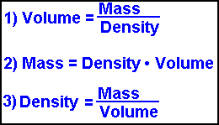Matter can be defined as the amount of a substance to exist or any object which has a mass and occupies space

#### Solve Questions using the density formula

* 1. Density (p) is the mass per volume of an object
  2. It can be calculated by the formula:

Density= Mass/Volume or p=m/V

* 1. Example question: An ice block has a volume of 125cm3 and has a density of 5g/cm3, what is the mass of the ice block?
  2. Answer: 625 grams

#### Define the Law of conservation of mass:

* 1. The law of conservation of mass states that mass in an isolated system can neither be created or destroyed,
  2. Energy is only transferred into different forms and the total mass of the reactants in a chemical reaction equals the sum of the mass of the products
  3. It prevents gas from escaping
  4. Example: Barium Chloride + Sodium Sulphate → Sodium Chloride +

Barium Sulphate.

* 1. As seen above, none of the chemicals are lost and all of them are just displaced or changed positions hence nothing is being destroyed or created

## Classification of Matter

#### Identify the difference between atoms, elements, compounds and mixtures in terms of physical and chemical properties

* 1. **Atoms** - Smallest part of any element while still retaining the properties of that element. Made up of protons, neutrons and electrons which are the 3 subatomic particles. Example:

Hydrogen atom, gold atom

* 1. **Element-** Substance made up of only one type of atom. Example: Gold, Silver, Iron.
  2. **Compound-** Composed of two or more different atoms chemically bonded which cannot be separated by physical means . Atoms are in a fixed ratio such as H2O2 or H2O
  3. **Mixture** - Composed of two or more different atoms that are not chemically bonded and can be separated by physical means, example salt and water
  4. **Molecule** - two atoms (same or different) chemically bonded. Can be a molecular element or molecular compound.
  5. **Atoms** are the smallest particles which make up elements, compounds and mixtures. While elements are made of only an atom and the number of atoms determines the chemical and physical properties of an element. Two or more elements or atoms form either compounds or mixtures, where the only difference would be that compounds are chemically bonded and cannot be separated physically while mixtures are not chemically bonded and can separate physically.

#### Illustrate the differences between pure and impure substances

* 1. A pure substance is an element or compound which contains only one substance with no other substances acting as an impurity or it can be defined as a

substance which has a uniform atomic structure where all the molecules are uniform and have the same build. It is has a clear melting point. It is always homogeneous.



* 1. Whereas an impure substance or mixture would be many different elements or compounds mixed together where there can be a mix of different molecules made up for different atoms. It does not have a clear/definite melting point. It is usually a mixture and is always heterogeneous.



## 

## States of Matter

#### Describe the states of matter with examples, talk about density, kinetic energy and arrangement of particles and attraction of particles

* 1. Solids
     1. Densely packed together
     2. Particles are strongly attracted to each other
     3. Can’t flow and has a definite shape and volume
     4. Not easily compressible
     5. Low kinetic energy
     6. Since the solids are tightly packed and are very dense they are hard and have a solid shape
     7. Vibrations along a fixed position
     8. Examples: Wood, Paper, Plastic
  2. Liquid
     1. Less densely packed compared to solids
     2. Particles are attracted to each other
     3. Can slide past each other
     4. Cannot hold a specific shape on their own and take the shape of their container
     5. Since the molecules are more loosely packed the molecules flow over each other thus can't hold a specific shape
     6. Lack of density means there is more space for the particles to vibrate around hence generating more kinetic energy
     7. Examples: Water, juice, soda
  3. Gas
     1. Particles are loosely packed together
     2. There is a lot of space between particles hence there is a lot of kinetic energy generated as the particles can move around more freely
     3. Can’t hold their shape
     4. Attract each other very slightly
     5. Free to move around
     6. Examples: Oxygen, Carbon Dioxide, methane

#### Describe the properties and the associated particle arrangement in each of the three states of matter

* 1. Answered Above^^^

#### Identify a link between STP and gas volume

* 1. STP refers to the Standard temperature and pressure
  2. Standard temperature is 273 K/ 0 degree celsius at standard atmosphere pressure of 1 ATM
  3. 1 atm = 101 kPa
  4. At STP, one mole of gas occupies 22.7L of volume (space)
  5. When pressure increases then the volume of gas decreases

1. **Identify changes of state from a graph**

## Temp

#### Explain the interconversion of states of matter in terms of kinetic energy

* 1. When a substance changes from solid to liquid there would be a gain in kinetic energy because there is more space for the particles to move around and the same applies for liquid to gas
  2. While when an object move from gas to liquid and liquid to solid there is a decrease in the amount of kinetic energy.

## Kinetic Theory

#### Define and explain what is meant by kinetic theory

* 1. The kinetic theory is a theory which explains the physical properties of matter in terms of motions of its constituent particles as shown above.
  2. Less dense particles, gas particles or ones with greater kinetic energy due to temperature, occupy more volume with the same mass and rise whereas cooler and more solid particles sink as they are denser.

#### Describe kinetic theory in terms of movement of particles whose average energy is proportional to temperature

* 1. As temperature rises and there is a conversation in the states of matter for example from solid to liquid, there is more space for the particles to move around thus more kinetic energy is being produced by the substance or particles.
  2. The higher the temperature the faster the particles move around thus movement of particles and temperature are directly proportional

#### Describe the particle movement as translational, vibrations and rotations

* 1. Translational: is the motion of a molecule as a whole moving from place to place
  2. Rotational motion: is the motion of a turning molecule
  3. Vibrational motion: is the back and forth movement of a vibrating molecule

#### Investigate brownian motion

* 1. Brownian motion is named after a botanist Robert Brown who first observed this in 1827
  2. Particles in both liquids and gases move randomly. This is called Brownian motion, they do this because they are bombarded by the other moving particles in the fluid (liquids and gases). Larger particles can be moved by light or fast moving particles
  3. The higher the temperature the faster the particles move around thus movement of particles and temperature are directly proportional.

## Diffusion

#### Define the term diffusion

* 1. Diffusion occurs when particles spread.
  2. They move from region where they are in high concentration to a region where they are in a lower concentration.
  3. Essentially the movement of molecules from regions of high concentration to regions or low concentration to fill their entire container/ environment.

#### Deduce the factors that affect movement of particles

* 1. Temperature has an an effect as higher temperatures cause particles to move faster since they have more kinetic energy.
  2. Mass of particles have an effect as well in which heavier particles will diffuse slower as described in Graham’s Law. If a particle’s molar mass is greater than another particles then it will diffuse slower.
  3. Chemical factors such as concentration difference and electric charges can play a huge role in the speed of diffusion

#### Describe the dependence of rate of diffusion on molecular mass

* 1. Smaller molecules will diffuse faster than larger molecules due to the difference in their molecular mass.
  2. Based on Graham’s Law, the rate of diffusion of gas is inversely proportional to the square root of its molecular mass.

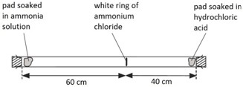

In the experiment above, HCl and Ammonia solution are soaked in steel/ cotton wool and placed on either side of a glass test tube placed horizontally. With time, a white ring of ammonium chloride (the product of HCl and ammonia) is formed. However, as you can see it is formed closer to the HCl and further away from the ammonia. This is because ammonia has a lower molar mass (17 g/mol) than HCl (36.5 g/mol) therefore it diffuses faster and the point where the 2 compounds meet is closer to HCl since the ammonia travelled more than the HCl in the given time frame.

## Terminology and Skills

#### Apply knowledge of scientific notation to convert numbers expressed in decimal format to normal numbers

* 1. Parallax error is the effect whereby the position or direction of an object appears to differ when viewed from different positions. Essentially, the volume of the liquid (usually water) in a glass container is measured either as too much or too little than it actually is due to the angle from which it is observed. To avoid this, scientists worldwide decided that to avoid parallax error, they would always measure from below the meniscus from eye level to get the most accurate (sorry reliable) value of the volume.
  2. The reason why a meniscus occurs is due to adhesion and cohesion. Adhesion (linking of unlike molecules) is when the molecules of the liquid (water) have a greater attraction to the molecules of the container (glass). It causes a concave meniscus. Cohesion (linking of like molecules) is when the molecules of the liquid are more attracted to themselves than the container, it causes a convex meniscus. One key example of cohesion is mercury in a glass test tube.
  3. NOTE: scientific notation ALWAYS HAS TO BE in the form N x 10^x where N MUST be between 1 and 10 and x is the power.

#### Measure the volume of different liquids, Taking into account meniscus

* 1. Meniscus is the curve in the upper surface of a liquid close to the surface of the container or another object caused by surface tension.
  2. It can either be concave or convex depending on the liquid and the surface
  3. The edge of the curve has to be inline with the desired measurement level for accurate measurements
  4. TIP: The correct level of water to refer to is where you see the curve or the vertex of the parabola (ultra cheeky math + chem link ;)

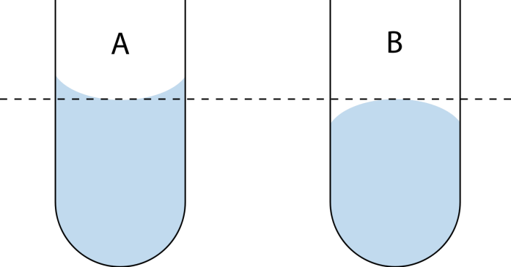

**Chapter 3.1:** Atomic Structure

|  |  |
| --- | --- |
| Sub Topic | Objectives |
| Atomic Structure | * State the position of protons, neutrons & electrons in the atom * Define the terms mass number (A) and atomic number (Z) * State the relative masses and relative charges of the subatomic particles * Draw the electronic configuration for atoms up to Z=20 * Determine valency of electrons using electronic structure * Define Ion * Evaluate the models for atomic theory * State evidence for the existence of atomic energy levels |
| Isotopes | - Define the term ‘isotope’ |

## Atomic Structure

#### State the position of protons, neutrons and electrons in the atom

* 1. Protons and neutrons are found at the core of the atoms also called the nucleus which is positively charged since the protons are positively charged and neutrons do not have a charge.
  2. There is a lot of space between the nucleus and the electrons but the electrons revolve around the nucleus in shells or orbits.
  3. Each shell can have a different amount of electrons. There is a general formula for the nth shell which is 2(n^2). For example, 1st shell = 2(1 x 1) = 2 electrons.

#### Define the terms mass number (A) and atomic number (Z)

* 1. Mass number refers to the total number of protons and neutrons present in the atom's nucleus. Mass number is always the bigger number when represented in the periodic table
  2. Atomic number refers to the total amount of protons present in an atom

#### State the relative masses and relative charges of the subatomic particles

* 1. When an atom loses or gains electrons then it is said to be an ion with either a negative or positive charge depending on whether it lost or gained electrons
  2. The term relative atomic mass refers to the total abundance of the certain substance in terms of its various isotopes. In essence it is the average mass of the element taking into account all isotopes in accordance to their abundances.
  3. Its calculated by the total percent of abundance of that isotope x (mass number) + the different isotopes with their mass numbers / 100
  4. Example (Chlorine): Chlorine has two isotopes which include Chlorine-35 which is around 75% of the total Chlorine, and Chlorine-37 which amounts to 25% of the total Chlorine. To calculate the relative atomic mass of Chlorine, we would take the mass of each isotope and multiply them by their % abundance and add them together and divide by 100. In this case; (35*75) + (37*25) / 100 = 35.5, which is the relative atomic mass of Chlorine.

|  |  |
| --- | --- |
| Protons | +1 |
| Neutrons | 0 |
| Electrons | -1 |

#### Define Ion

* 1. Ion is an atom or group of atoms which have a charge, either negative or positive. If it is a positive ion, it is called a cation, although, if it is negative, it is called an anion.
  2. OH= hydroxide and has a charge or -1
  3. NH4- Ammonium and has a charge of +1
  4. The compound NaCl: Na has a positive charge and Cl a negative charge (Na+Cl-)

#### Determine valency of electrons using electronic structure

* 1. Valency just refers to the outermost shells so if your able to organise the first 20 elements in their shells , then the electrons in the outermost shells are valence electrons
  2. For instance, if you have Oxygen which has 8 protons and 8 electrons in its neutral state, you can organize it into its electronic structure. In this case it would be 2, 6 which means that there are 2 electrons in Oxygen’s first shell, and 6 in its last shell, or valence shell. This means that Oxygen has 6 valence electrons.

1. **Evaluate the models for atomic theory**

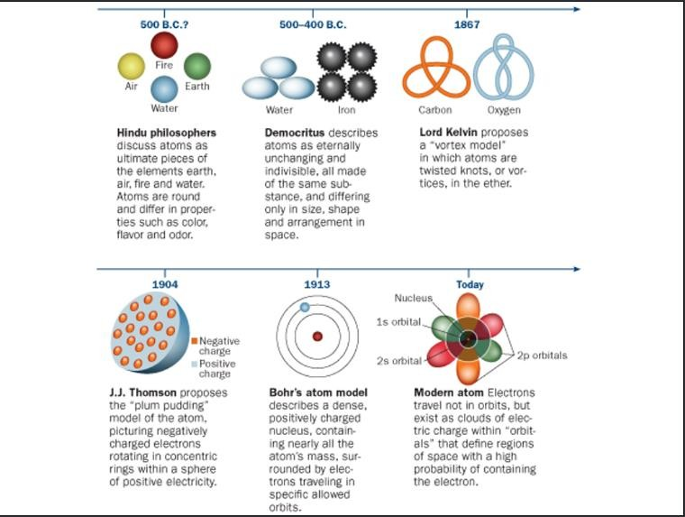

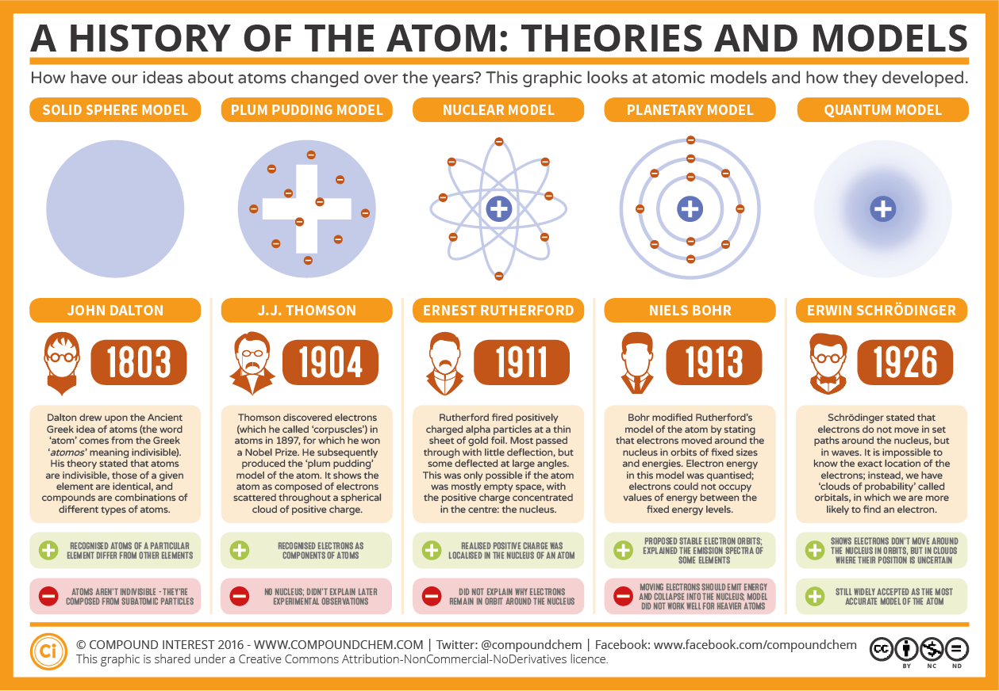

## Isotopes

#### Define the term ‘isotope’

* 1. Isotopes are atoms that retain the same chemical properties and atomic number of an element but have a different atomic mass due to change in the number of neutrons.
  2. Having a different amount of neutrons only affects the physical properties of the atom
  3. Some isotopes of different elements are radioactive, such as Carbon-14
  4. Carbon dating is measuring the ratio of Carbon-14 atoms to Carbon-12 atoms to determine how old an object is

**Chapter 3.2:** The Periodic Table

|  |  |
| --- | --- |
| Sub Topic | Objectives |
| The Periodic Table | * Distinguish between the terms ‘group’ and ‘period’ * Identify the relationship between and electronic arrangement of elements & their positions in the periodic table up to Z=20 * Identify the relationship between the number of electrons in the highest occupied energy level for an element & its position in the periodic table * Describe the history of the periodic table (Lavoisier, Döbereiner, Newlands, Mendeleev, Moseley, The modern periodic table) |

|  |  |
| --- | --- |
| Metals & Non- Metals | * Describe the properties of metals and Non- Metals and compare to metalloids * Suggest how metallic bonding explains the properties of metals * Outline how metals can be extracted in relation to the reactivity series |
| Groups In the periodic Table | * Outline the properties of the following groups:   + Groups 1 & 2: Electrical conductivity & Malleability   + Group 7: State at room temperature; Reactivity with metals   + Group 8: Inert * Outline the periodic trends for groups 1, 2, 7, & 8   + Atomic size   + Boiling and melting points   + Reactivity * Explain uses of different elements in Real life/ industry |
| Ions | * Deduce the ions formed when groups 1, 2, 3 lose electrons * Deduce the ions formed when groups 5, 6 ,7 gain electrons * State that the transition elements can form more than one ion, including examples * State the formula of common polyatomic ions |

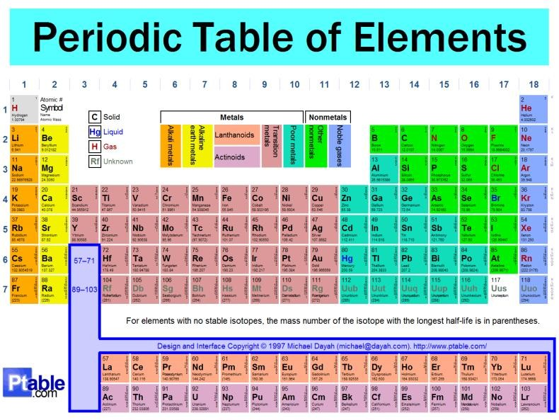

## The Periodic Table

#### Distinguish between the terms ‘Group’ and ‘Period’

|  |  |
| --- | --- |
| **Group** | **Period** |
| Groups are the vertical columns on the periodic table | Periods are the horizontal rows on the periodic table |
| There are 18 groups in the periodic table | There are 7 periods in the periodic table |

|  |  |
| --- | --- |
| Group numbers usually indicate the number of valence electrons in the atom of the elements (Excluding Transitional Metals) | Period numbers indicate the number of electron shells in the atom of the elements |

1. **Identify the relationship between electronic arrangement of elements & their positions in the periodic table up to Z=20**
   1. In an atom, there are electron shells and valence electrons that occupy them. As the atomic number increases, the number of electrons increase and so does the number of electron shells as well as the number of valence electrons.
   2. The number of electron shells in the atom of an element corresponds with the period number the element is located in the periodic table. If an atom has 2 electron shells, then it will be located in period 2 of the periodic table. Therefore, it can be said that the number of electron shells is equal to the period number.
   3. The number of valence electrons in the atom of an element corresponds with the group number the element is located in the periodic table. If an atom has 2 valence electrons, then it will be located in group 2 of the periodic table. Therefore, it can be said that the number of valence electrons is equal to the group number.

#### Identify the relationship between the number of electrons in the highest occupied energy level for an element & its position in the periodic table

* 1. The number of electrons occupied in the highest energy level (outermost shell) in an atom of a specific element signifies the group number the element is located in the periodic table. Ex: Oxygen has 6 electrons in the highest energy level (outermost shell) thus it is located in Group 6 of the periodic table.

#### Describe the history of the periodic table (Lavoisier, Döbereiner, Newlands, Mendeleev, Moseley, The modern periodic table)

* 1. Johann Wolfgang Döbereiner- he put them into triads
  2. Henry Moseley organized the table by atomic number (number of protons).
  3. John Newlands created the law of octets which states that every shell after the first one can hold up to a maximum of 8 electrons
  4. Lavoisier organized the elements into a list of substances
  5. Dmitri Mendeleev organized the elements in atomic masses and valencies to their chemical properties and left gaps for undiscovered elements.

## Metals and Non Metals

#### Describe the properties of metals and Non- Metals and compare to metalloids

|  |  |
| --- | --- |
| **Physical Properties** | |
| **Metals** | **Non-Metals** |
| Usually have high melting and boiling point | Low melting and boiling point |
| Good conductors of heat and electricity | Poor conductors of heat and electricity (Except Carbon - Graphite conducts electricity) |

|  |  |
| --- | --- |
| Solid state at room temperature (Except Mercury - Liquid) | Solid, liquid or gas at room temperature |
| Typically malleable and ductile - Can be made into different shapes and wires | Usually brittle - Breaks or shatters when hammered |
| Lustrous - Shines and reflects light attractively | Non-lustrous and do not reflect light |
| Sonorous - Makes a ringing sound when hit | Non-sonorous |
| Usually have high densities and are hard and strong | Usually have low densities and are weak |
| Metal atoms have 1 to 3 valence electrons | Non-metal atoms have 5 to 7 valence electrons |
|  | Non-ductile |

|  |  |
| --- | --- |
| **Chemical Properties** | |
| **Metals** | **Non-Metals** |
| Metals lose electrons easily | Non-metals share or gain electrons easily |
| Most metals form basic oxides | Most non-metals form acidic oxides |
| Metals act as a reducing agent as it gives electrons | Non-metals act as a oxidizing agent as it takes electrons |
| Firms positive ions |  |

**Metalloid** - A metalloid is any chemical element which has properties in between those of metals and non- metals.

|  |  |
| --- | --- |
| **Metalloids Properties** | |
| **Physical** | **Chemical** |
| Solid at room temperature | Forms alloys with metals |
| Metalloids are semiconductors as only some of them can conduct electricity under the right conditions such as silicon and germanium | React with halogens to form compounds |
| Dull and lustrous | Gain electrons when reacting with metals and lose electrons when reacting with non - metals |
| Brittle | The oxidation number can range from +3 to -2, depending on the group in which it is located |
| Conduct heat and electricity but not as well as metals |  |

|  |  |
| --- | --- |
| Often ductile and malleable |  |

#### Suggest how metallic bonding explains the properties of metals

* 1. 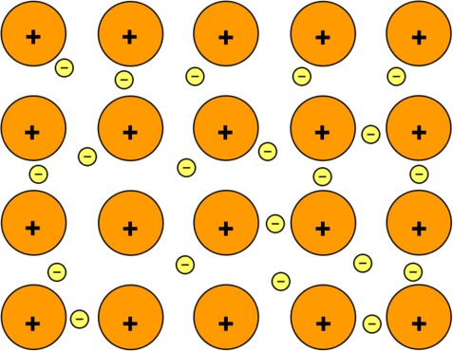Metallic bonding is the chemical bond that takes place between the atoms of the same metal. Metallic bonding occurs due to the electrostatic force of attraction between the metal cations and the free flowing delocalized electrons.
  2. Metallic bonds have a very strong force of attraction between the atoms and as a result, large amounts of energy are required to break this bond. Thus, the melting and boiling points of these bonded atoms are high.
  3. The space between the cations allow for the movement of the delocalised electrons which allows the atoms to conduct heat and electricity
  4. The bonded atoms are arranged in layers which slide over each other easily and are therefore malleable and ductile.

#### Outline how metals can be extracted in relation to the reactivity series

* 1. The method used to extract metals from the ore in which they are found depends on their reactivity. For example, reactive metals such as aluminium are extracted by electrolysis, while a less-reactive metal such as iron may be extracted by reduction with carbon or carbon monoxide.
  2. Thus the method of extraction of a metal from its ore depends on the metal's position in the reactivity series:

1. See this website: <https://www.bbc.com/bitesize/guides/zsm7v9q/revision/3#glossary> 5.

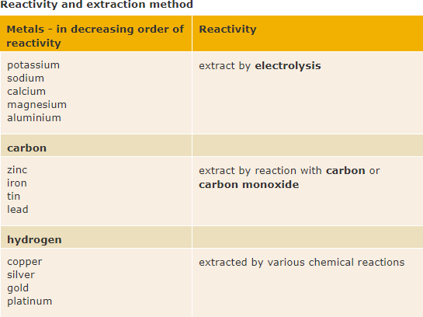

## Groups in the Periodic Table

#### Outline the properties of the following groups:

* 1. **Groups 1 & 2: Electrical conductivity & Malleability**
     1. Since these groups are metals, they have a relatively high conductivity as there are more carriers which allow for the transfer of current due to the fact that they are metallically bonded.
     2. In the case of metals and elements in Group 1 & 2, the reactivity increases as the period number increases. This means that elements located further down the table in Groups 1 and 2 are more reactive.
     3. This is because the force of attraction between the electrons and the nucleus is weaker as the distance between them is greater. This happens because the atomic radius increases and therefore the distance increases which makes the force of attraction weaker. Because of this, it is easier for the atom to lose electrons and react as compared to elements with a smaller radius.
     4. As we go down the group the melting point and boiling point decreases whereas density increases apart from Sodium and Potassium where K has a lower density than Na

#### Group 7: State at room temperature; Reactivity with metals

* + 1. The Halogens are the most reactive nonmetals in the periodic table. It can be said that the higher up the element is located in the group, the more reactive it is for non - metals.
    2. This is because the force of attraction between the electrons and the nucleus is greater as the distance between them is low. As the atomic radius is relatively the smallest, the distance is the least and therefore the force of attraction is greater. Because of this, it is easier for the atom to gain electrons and react as compared to elements with a larger radius.
    3. In the case of group 7, fluorine is most reactive and astatine is least reactive. A similar trend applies for the physical state of the elements in room temperature. The more reactive elements, fluorine and chlorine, are gases followed by bromine which is liquid and then iodine and astatine which are least reactive and are solids.

#### Group 8: Inert

* + 1. Elements in group 8 of the periodic table are inert or unreactive because they have complete outermost shells. These elements have no valence electrons and therefore have complete and full outermost shells.
    2. Because of this, the elements don’t have to react in order to lose or gain electrons

to obtain a full outermost shell.

#### Outline the periodic trends for groups 1, 2, 7, & 8

* 1. **Atomic size** - The trend in the atomic sizes of elements for all groups on the periodic table are the same. As the atomic number increases so does the number of electrons and therefore electrons shells. When there are more electron shells, the atom becomes bigger and has a larger radius and overall increases in atomic size.

|  |  |  |  |  |
| --- | --- | --- | --- | --- |
|  | **Group 1** | **Group 2** | **Group 7** | **Group 8** |
| **Smallest** | Lithium | Beryllium | Fluorine | Helium |
| **Biggest** | Francium | Radium | Astatine | Radon |

* 1. **Boiling and melting points** - The melting and boiling point trend for elements in group 1 and 2 are similar to each other but different to the trend in elements in group 7 and 8 which are also similar to each other. The trend in the elements in groups 1 and 2 is that the higher up the element is located in the group, the higher the melting and boiling point it has. Whereas, the trend in the elements in groups 7 and 8 is that the lower down the element is located in the group, the higher the melting and boiling point it has.

|  |  |  |  |  |
| --- | --- | --- | --- | --- |
|  | **Group 1** | **Group 2** | **Group 7** | **Group 8** |
| **Highest** | Lithium | Beryllium | Astatine | Radon |
| **Lowest** | Francium | Radium | Fluorine | Helium |

* 1. **Reactivity** - Similar to the melting and boiling point trend, the reactivity of elements in group 1 and 2 are the same but different to the reactivity of elements in group 7. The trend in elements in groups 1 and 2 is that the lower down the element is located in the group, the more reactive it is. Whereas for group 7 elements, the higher up the element is located in the group, the more reactive it is. Group 8 elements are an exception as they do not naturally react in nature at all as they are inert and so there is no observable reactivity trend.

|  |  |  |  |  |
| --- | --- | --- | --- | --- |
|  | **Group 1** | **Group 2** | **Group 7** | **Group 8** |
| **Most** | Francium | Radium | Fluorine | - |
| **Least** | Lithium | Beryllium | Astatine | - |

#### Explain uses of different elements in Real life / industry

* 1. Sodium - Sodium is used in real life to de - ice roads by adding it to the ice.
  2. Beryllium - Beryllium is used in alloys with nickel or copper to make sprigs and electrodes.
  3. Aluminium - Aluminium is used to make foils, cans, kitchen utensils and aeroplane parts.
  4. Carbon - Carbon is used in pencil tips, electrodes and lubricants (graphite)
  5. Nitrogen - Nitrogen is used to make fertilizers for plants and crops.
  6. Oxygen - Oxygen is used in industry for the manufacturing of steel.
  7. Chlorine - Chlorine is used to make water safe for drinking as well as treating swimming pools.
  8. Helium - Helium is used to inflate blimps and balloons.

## Ions

#### Deduce the ions formed when groups 1, 2, 3 lose electrons

* 1. The formation of ions is a process that makes the atoms electronic structure more stable. Metal atoms form groups 1, 2 and 3 lose all of their outer shell electrons when forming ions. As each electron corresponds to a negative charge then the loss of one electron produces a positive ion with one positive charge. The loss of two electrons produces a positive ion with two positive charges etc.
     1. Group 1 metals form single positive ions
     2. Group 2 metals form double positive ions
     3. Group 3 metals form triple positive ions
  2. **These rules do not apply to the transition metals.**

1. **Deduce the ions formed when groups 5, 6 ,7 gain electrons**
   1. Atoms in groups 5, 6 and 7 gain electrons to obtain a full outer shell. This means that atoms in group 6 form ions with a double negative charge and atoms in group 7 form ions with a single negative charge.
      1. Oxygen (configuration 2, 6) forms oxide ions (configuration 2,8), O2-
      2. Sulfur (configuration 2, 8, 6) forms sulfide ions (configuration 2, 8, 8), S2-
      3. Fluorine (configuration 2, 7) forms fluoride ions (configuration 2,8), F-
      4. Chlorine (configuration 2, 8, 7) forms chloride ions (configuration 2, 8, 8), Cl-
   2. Non-metals gain just enough electrons to fill their outer shells. Each electron gained corresponds to a negative charge and so group 6 non-metals form double negative ions.

i. Sulphur (2,8,6) --> [sulphide ion (2,8,8)]2-

1. Similarly group 7 elements need only one electron for a full outer shell and so form single negative ions.
2. Chlorine (2,8,7) --> [chloride ion (2,8,8)]-

#### State that the transition elements can form more than one ion, including examples

* 1. The normal rules do not apply to the transition metals as they can form more than one type of ion. The reason for this lies in the electronic configuration which involves electrons from the 3rd level called 'd' electrons.
     1. Example: Fe2+ Fe3+
  2. In these two ions the Iron atoms have lost either two electrons (in the case of Fe2+) or three electrons (in the case of Fe3+). This type of behaviour is possible for all of the transition metals.

#### State the formula of common polyatomic ions

|  |  |
| --- | --- |
| **Type Of Ion** | **Formula** |
| Nitrate | NO3 {-} |

|  |  |
| --- | --- |
| Hydroxide | OH {-} |
| Sulfate | SO4 {2-} |
| Carbonate | CO3 {2-} |
| Phosphate | PO4 {3-} |
| Ammonium | NH4 {+} |
| Hydrogen carbonate | HCO3 {-} |

**Chapter 4:** How do atoms bond? (Bonding)

|  |  |
| --- | --- |
| Subtopic | Objectives |
| Valency | * Identify the charges on atoms in a compounds * State that transition metals can form more than one ion, including examples * State the formula and charges on common polyatomic ions |
| Balancing Equations | * Describe the law of conservation of mass * State the rules to be followed when balancing chemical equations * Balance Chemical equations |
| Ionic Bonding | * Describe how ions are formed as a result of electron transfer * Describe the process of ionic bonding using scientific terminology * Name and write the correct chemical formula of ionic compounds |
| Covalent Bonding | * Describe how a covalent bond is formed using scientific terminology * Identify differences between single, double and triple bonds * Illustrate a covalent bond * Describe & compare carbon allotropes (diamond, graphite, graphene & C60 fullerene) * Describe and compare simple and giant covalent structures (silicon dioxide and silica) |
| Metallic Bonding | * Describe the metallic bond using scientific terminology * Illustrate a metallic bond * Create links between the bonding which occurs in metals and the properties of metals |
| Skill | * Compare and explain the properties of substances resulting from different types of bonding * Draw both lewis structure and dot and cross diagrams to represent bonding * Differentiate between intermolecular and intramolecular forces of attraction and include examples |

## Valency

#### Identify the charges on atoms in a compounds

* 1. An atom can either be
     1. Positively charged (more protons than electrons)
     2. Negatively charged (more electrons than protons)
     3. Neutrally charged (Equal amounts of protons and electrons)
  2. In a compound, both elements have to cancel out each other resulting in a neutral charge such as
     1. NaCl - Na or sodium has a charge of +1 as it is a group 1 metal and donates one electron whereas Chlorine is a group 7 non metal and gains one electron thus have a -1 charge. So when they chemically bond, their charges cancel each other out and are neutral

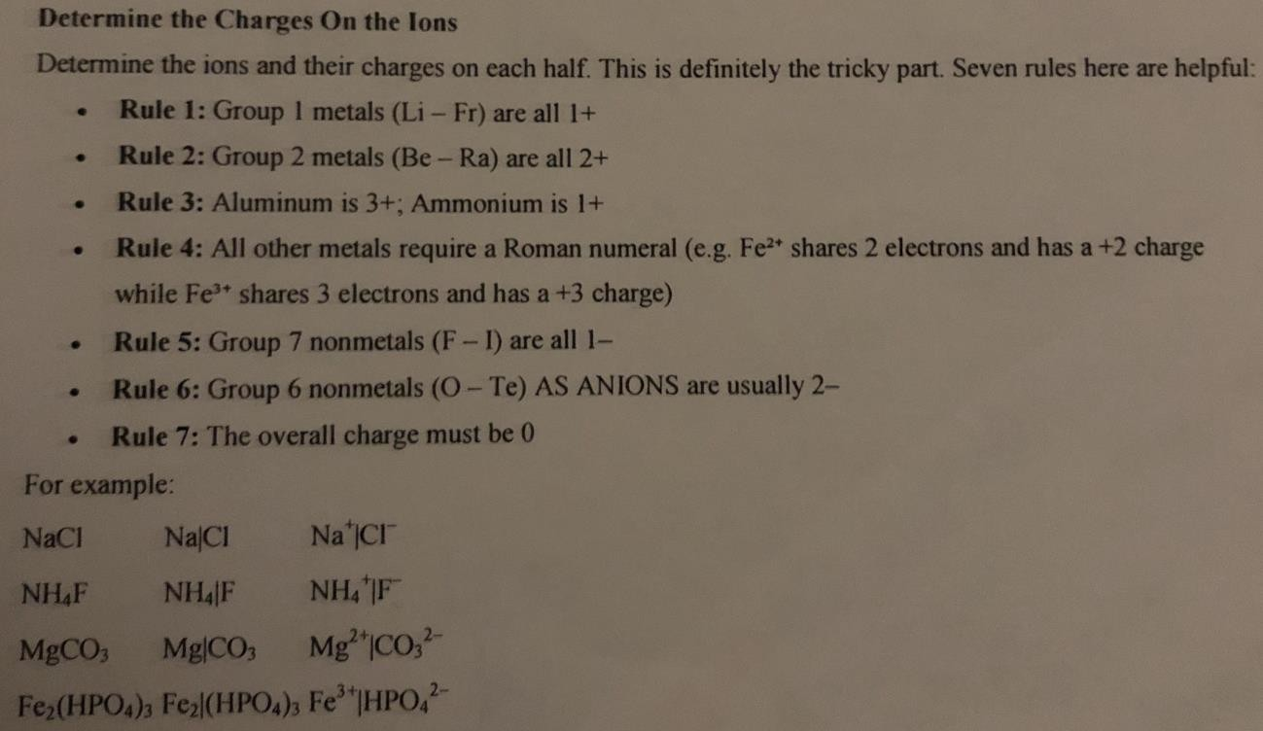

#### State that transition metals can form more than one ion, including examples

* 1. Transition metals located between groups 3 and 12 can share different amounts of electrons which causes for them to form more than one ion
  2. Example- Iron(II) and Iron(III) this varies due to the fact in Iron(II) only two electrons are shared whereas in Iron (III) 3 electrons are shared

1. **State the formula and charges on common polyatomic ions**

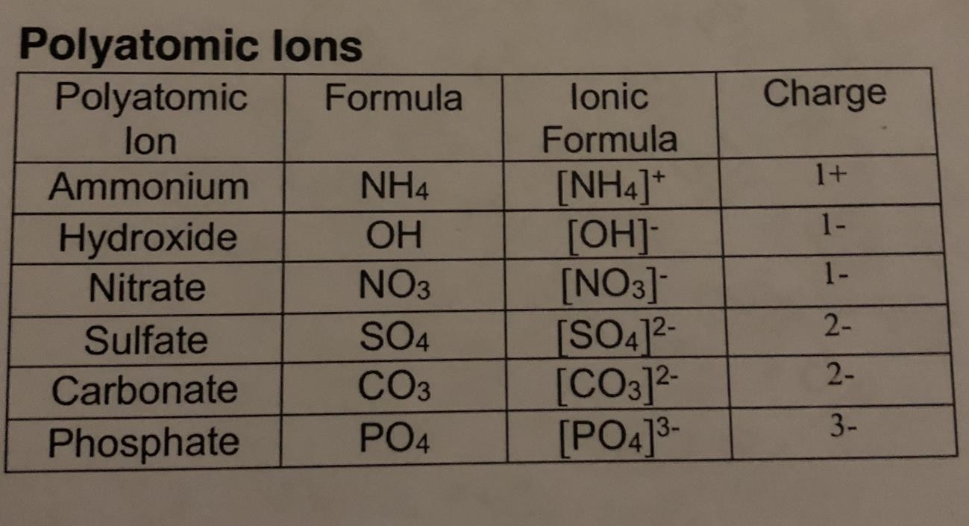

## Balancing Equations

#### Describe the law of conservation of mass

* 1. The law of conservation of mass states that matter can neither be created nor destroyed and only transferred from one state to another

#### State the rules to be followed when balancing chemical equations

* 1. Rule 1 - If two identical elements combine then the name does not change
     1. H2 = Hydrogen
     2. F2 = Fluorine
     3. O2 = Oxygen
  2. Rule 2 - When two elements join, the end is usually ide
     1. Magnesium + Oxygen = Magnesium Oxide
     2. Lithium + Iodine = Lithium Iodide
     3. Oxygen + Iron = Iron Oxide
     4. KBr = Potassium bromide
     5. CaO = Calcium Oxide
  3. Rule 3 - When 3 or more elements combine and one of them is oxygen is ate
     1. Copper + Sulphur + Oxygen → Copper sulfate
     2. Calcium Carbonate
     3. Silver nitrate

#### Balance Chemical equations

* 1. Check Edmodo for worksheets

## Ionic Bonding

#### Describe how ions are formed as a result of electron transfer

* 1. For an atom to gain stability, it needs to have 8 electrons in the valence shell as per the octet rule (exception for the first shell where it needs to have 2 electrons)
  2. Atoms gain such stability through the giving or taking of electrons from the valence shells.

This creates ions

* 1. Ions are charged atoms
  2. A Cation is a positively charged atom (usually a metal and donated its electrons)
  3. An Anion is a negatively charged ion where it has received an electron. (usually tends to be Non metals)

#### Describe the process of ionic bonding using scientific terminology

* 1. A chemical bond formed between nonmetals and metals with opposite charges. Ionic bonds form when one atom gives up one or more electrons to another atom.
  2. In Ionic bonding, it can be said that the metals are ‘electron donors’, whilst the non-metals are ‘electron recievers’. These bonds can form between a pair of atoms or between molecules and are the type of bond found in salts.
  3. Usually happens between metal and non metal
  4. Ionic bonding occurs because the transfer of electrons causes opposite charges on the ions (donator becomes positively charged, and receiver becomes negatively charge), this leads to a strong electrostatic force of attraction which forms the ionic bond.

#### Name and write the correct chemical formula of ionic compounds

* 1. Sodium chloride consists of Na+ ions and Cl- ions bound together.
  2. Magnesium oxide consists of Mg2+ ions and O2- ions bound together.

## Covalent Bonding

#### Describe how a covalent bond is formed using scientific terminology

* 1. Covalent bonds usually join a non metal to another non metal.
  2. A Covalent bond is when two nonmetals share their valence electrons in order to gain chemical stability

#### Identify differences between single, double and triple bonds

* 1. Single bonds are when one pair of electrons is shared by two atoms in a molecule
  2. Double bonds are when two pairs of electrons are shared by two atoms in a molecule
  3. Triple bonds are when three pairs of electrons are shared by two atoms in a molecule

#### Illustrate a covalent bond

**a.**

#### Describe & compare carbon allotropes (diamond, graphite, graphene & C60 fullerene)

* 1. Carbon Allotropes are the different forms of carbon which exist due to the fact that their strong covalent bonds have very different arrangements. There are three main types -
     1. Graphite - Formed when carbon atoms are bonded and are arranged together into layers over each other with weak intermolecular forces
     2. Diamond - Carbon are bonded to 4 other carbon atoms called as a tetrahedral bond and is arranged into a crystal lattice structure.
     3. Buckminsterfullerene - Fullerenes are made from carbon atoms joined together to

make balls, ‘cages’ or tubes of carbon.

* + 1. Use this link for more detailed info - [http://www.bbc.co.uk/schools/gcsebitesize/science/add_gateway_pre_2011/chem](http://www.bbc.co.uk/schools/gcsebitesize/science/add_gateway_pre_2011/chemical/nanochemistryrev1.shtml) [ical/nanochemistryrev1.shtml](http://www.bbc.co.uk/schools/gcsebitesize/science/add_gateway_pre_2011/chemical/nanochemistryrev1.shtml)

#### Describe and compare simple and giant covalent structures (silicon dioxide and silica)

* 1. Simple molecules contain only a few atoms held together by strong covalent bonds. An example is carbon dioxide (CO2), which contain one atom of carbon bonded with two atoms of oxygen. Their properties are as follows:
     1. Low Melting and Boiling Points - Simple covalent structures have very strong intramolecular bonds between the **atoms** but weak intermolecular forces holding the molecules together. Due to this, these molecules have low melting and boiling points as it requires less heat energy to break these weak forces.
     2. Non Conductive - substances with a simple molecular structure do not conduct electricity. This is because they do not have any free delocalised electrons or an overall electric charge
  2. Giant covalent molecules contain many atoms that are arranged in a crystal lattice structure. Their properties are as follows:
     1. Strong - The physical arrangement of atoms into a lattice structure give them a strong shape as there are multiple strong forces between these bonds.
     2. High Melting and Boiling Points - Due to multiple bonds being present between these atoms and molecules and strong intermolecular forces, lots of heat energy is required to break them and change the physical state of the molecules.
     3. More info at this link - [http://www.bbc.co.uk/schools/gcsebitesize/science/add_aqa/bonding/structure_p](http://www.bbc.co.uk/schools/gcsebitesize/science/add_aqa/bonding/structure_propertiesrev2.shtml) [ropertiesrev2.shtml](http://www.bbc.co.uk/schools/gcsebitesize/science/add_aqa/bonding/structure_propertiesrev2.shtml)

## Metallic Bonding

#### Describe the metallic bond using scientific terminology

* 1. Metals already consist of a continuous lattice of positive ions within a sea of delocalized electrons. This sea of electrons are the ones involved in chemical reactions or valence electrons.
  2. The electrical attraction between these delocalized electrons and the positive metal ions explain how the atoms of metal are bonded.
  3. This attractions occurs in all directions and decreases with distance. As a consequence, metallic bonds are able to resist forces such as bending or hitting the metal with a hammer. Instead the ions slip to new relationships with delocalized electrons.
  4. Metals are insoluble, although some will react with water to produce a soluble product.

#### Illustrate a metallic bond

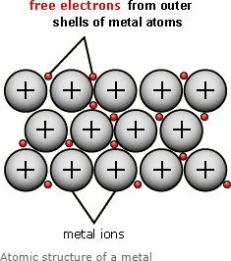

1. **Create links between the bonding which occurs in metals and the properties of metals**
   1. Metallic bonding is the chemical bond that takes place between the atoms of the same metal. Metallic bonding occurs due to the electrostatic force of attraction between the cations and the free flowing delocalized electrons.
   2. Metallic bonds have a very strong force of attraction between the atoms and as a result, large amounts of energy are required to break this bond. Thus, the melting and boiling points of these bonded atoms are high.
   3. The space between the cations allow for the movement of the delocalised electrons which allows the atoms to conduct heat and electricity
   4. The bonded atoms are arranged in layers which slide over each other easily and are therefore malleable and ductile.

## Skills

**1. Differentiate between intermolecular and intramolecular forces of attraction and include examples**

|  |  |
| --- | --- |
| **Intermolecular** | **Intramolecular** |
| Intermolecular forces are the forces that exist between molecules | Intramolecular forces are the forces that exist within a molecule |
| Intermolecular forces include: (in order of strength from least to greatest)   * London Dispersion Attraction * Dipole - Dipole Interactions * Hydrogen Bonding | Intramolecular forces include:   * Metallic Bonding * Ionic Bonding * Polar Covalent Bonding * Nonpolar Covalent Bonding |

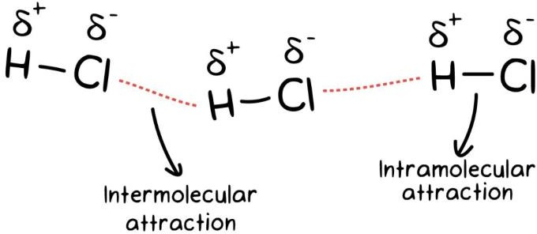

# **Chapter 5:** What are the impacts of the chemical industry? (Acids & Alkalis)

|  |  |
| --- | --- |
| Subtopic | Objectives |
| Acids and Alkalis | * Define an acids as a Proton/H+ donor and a base proton/H acceptor * Distinguish between aqueous solutions that are acidic, neutral or alkaline using the pH scale * State the formula of common acids and bases * Describe strong and weak acids and bases in terms of the extent of ionization * Describe that strong acids and bases of equal concentrations have higher conductivities than weak acids and bases * Distinguish between strong and weak acids and bases in terms of the rates of their reactions with metals, metal oxides, metal hydroxides, metal hydrogen carbonates and * metal carbonates and their electrical conductivities for solutions of equal concentrations |
| Neutralization | * Define neutralization reactions * Identify the acid and base needed to make different salts and write balanced equations to represent reactions * Explain the use of neutralization in everyday life |
| Skills | * Identify products and reactants in a chemical equation * Classify substances using state symbols * Identify reactions as ‘displacement’ or ‘precipitate’ reactions * Balance chemical equations for the reaction of acids with metals, metal oxides, metal hydroxides, hydrogen carbonates and carbonates |

## Acids and Alkalis

#### Define an acids as a Proton/H+ donor and a base proton/H acceptor

* 1. An acid is defined as a chemical substance that when dissolved in water, or disassociated, can

donate hydrogen ions, H+, or a proton. They are solutions of pure compounds in water. They are also defined as an acid by the following properties:

* + 1. pH - Less than 7
    2. Turn Litmus Paper from Blue to Red
    3. Sour Taste
    4. Corrosive, (when concentrated)
    5. Turn universal indicator from Green to Red.
  1. A base is defined as a chemical substance that when dissolved in water or disassociated, donates OH- ions and they neutralize acids. They are also defined as a base by the following properties:
     1. pH - More than 7
     2. Doesn’t change Blue Litmus paper, however can turn red litmus paper back into blue

litmus paper

* + 1. Soapy or Bitter Taste
    2. Corrosive, only to the skin and not metals
    3. Dissolves fats and oils.
    4. Neutralizes Acids
    5. Turn universal indicator from Green to Dark Violet.

#### Distinguish between aqueous solutions that are acidic, neutral or alkaline using the pH scale.

* 1. pH refers to the power of hydrogen and measures the concentration of an acid or alkali with the concentration of Hydrogen ions in an acidic, basic or neutral solution. It is logarithmic, so each denomination is equal to the power of 10, with the sign reversed. **Example** - Pure Water has a H+ *concentration of 10-7 mol/dm3* so its pH is 7.

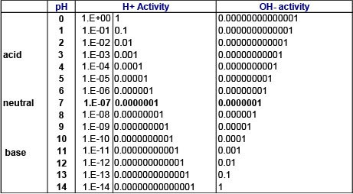

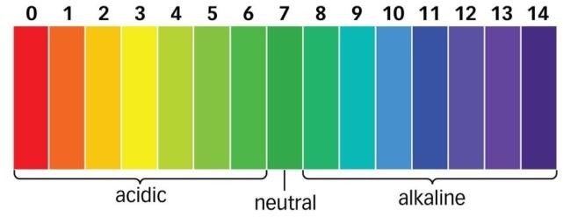

**Acids** - Range from 0-6 on the pH scale.

**Bases** - Range from 8-14 on the pH scale.

**Neutral Solution** - 7 on the pH scale.

#### State the formula of common acids and bases.

|  |  |  |
| --- | --- | --- |
| **Common Acids** | | |
| **Type of Acid** | **Name** | **Formula** |
| Monoprotic | Hydrochloric Acid | HCl |
| Ethanoic Acid (Acetic Acid) | CH3COOH |
| Nitric Acid | HNO3 |
| Diprotic | Sulfuric Acid | H2SO4 |
| Carbonic Acid | H2CO3 |
| Chromic Acid | H2CrO4 |
| Triprotic | Phosphoric Acid | H3PO4 |

|  |  |
| --- | --- |
| **Bases** | |
| **Name** | **Formula** |
| Sodium Bicarbonate | NaHCO3 |
| Ammonia | NH3 |
| Calcium Hydroxide | Ca(OH)2 |
| Lithium Hydroxide | LiOH |
| Potassium Hydroxide | KOH |
| Sodium Hydroxide | NaOH |

1. **Describe strong and weak acids and bases in terms of the extent of ionization.**
   1. When an **acid** dissolves in water, it donates a hydrogen ion or a proton to produce a hydronium ion and a negative ion. These are often reversible.
   2. Sometimes the acid donates a large amount of its Hydrogen ions, so much so that it can be said that very little of the reverse reaction takes place, therefore It can be said that the acid is virtually



100% ionized.



* 1. If at any one time, virtually 100% of the hydrogen ions of the acid have formed hydronium ions, it can be said that the acid is a strong acid.
  2. Weak **acids** are acids that don’t fully dissociate when in water. The acid does still react with water to form a salt and hydronium ion, however the reverse reaction easily takes place and is more common than the dissociation reaction. The ions react very easily to form the acid and water, so only a small part of the solution is ionized. If at any one time, if virtually 1% of the hydrogen ions of the acid have formed hydronium ions, it can be said that the acid is a weak acid.
  3. When a **base** dissolves in water, it donates a Hydroxide ion. These are often reversible. Sometimes the alkali donates a large amount of its Hydroxide ions, so much so that it can be said that very little of the reverse reaction takes place, therefore It can be said that the alkali is virtually 100% ionized. If at any one time, virtually 100% of the Hydroxide ions of the alkali have dissociated and forms Hydroxide ions, it can be said that the alkali is a strong alkali.
  4. Weak **bases** are bases, that don’t fully dissociate when in water. The alkali does still react with water to dissociate, however the reverse reaction easily takes place and is more common than the dissociation reaction. The ions react very easily form the alkali and water, so only a small part of the solution is ionized. If at any one time, virtually 1% of the hydrogen ions of the acid have formed hydroxide ions, it can be said that the acid is a strong acid.

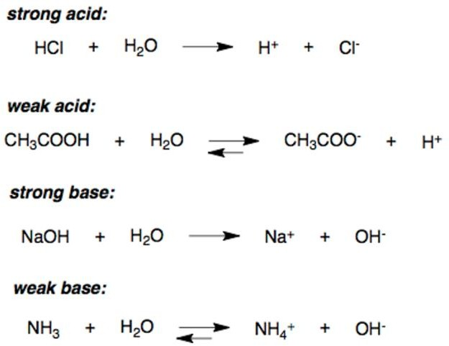

#### Concentration vs Strength.

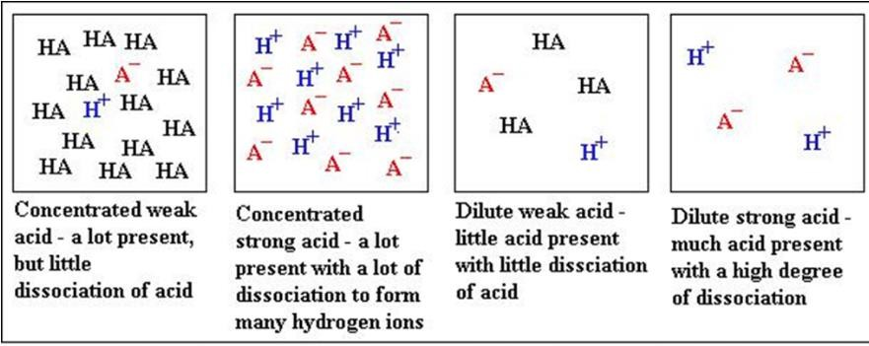

*same principle applies to Hydroxide ions.

#### Describe that strong acids and bases of equal concentrations have higher conductivities than weak acids and bases.

* 1. Any solution's ability to conduct electricity is based on the concentration of ions. A strong acid has more ions than a weak one, and so it's solution will be a better electrical conductor than a weak acid. The same can be said for strong/weak bases.

#### Distinguish between strong and weak acids and bases in terms of the rates of their reactions with metals, metal oxides, metal hydroxides, metal hydrogen carbonates and metal carbonates and their electrical conductivities for solutions of equal concentrations.

* 1. Strong acids and bases will have a greater rate of reaction with metals, metal oxides, metal hydroxides, metal hydrogen carbonates and metal carbonates.
  2. Even if the concentration of both the strong and weak acid or base was kept constant, the stronger the acid or base, the greater the rate of reaction because there are more hydrogen and hydroxide atoms that are dissociated allowing for a quicker reaction
  3. If equal amounts of a substance was reacted with a weak or strong acid or base, the amount of product formed would be the same for all solutions. However, strong acids and bases would produce maximum products quicker.

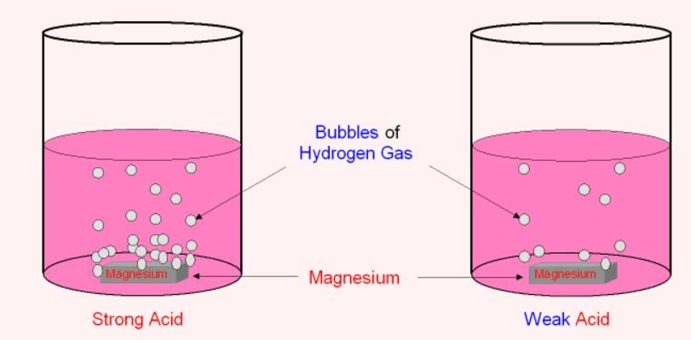

## Neutralization

#### Define a neutralization reaction.

* 1. A neutralization reaction is a chemical reaction that takes place when an acid reacts with a base to form a salt and water. When reacting with an alkali, the OH- ions react with the H+ ions to form water.

#### Explain the use of neutralization in everyday life

* 1. Milk of magnesia - Antacid or base which helps in neutralizing stomach acids
  2. Limestone for agriculture

#### Identify reactions as ‘displacement’ or ‘precipitate’ reactions.

* 1. Double replacement reactions have two ionic compounds that are exchanging anions or cations. Precipitation reactions and neutralization reactions are two common types of double replacement reactions. Precipitation reactions produce an insoluble product from two aqueous reactants, and you can identify a precipitation reaction using solubility rules. Neutralization reactions occur when the reactants are an acid and a base, and neutralization reactions are usually favorable as long as the reaction involves a strong acid and/or a strong base.

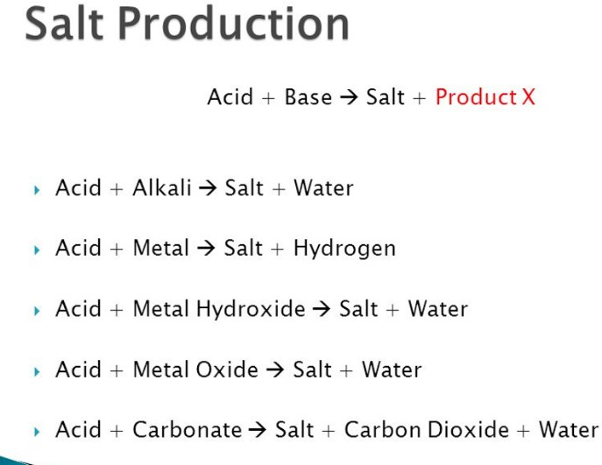

# **Chapter 6:** What determines chemical change? (Stoichiometry)

|  |  |
| --- | --- |
| Subtopic | Objectives |
| Moles | - Define the term mole |

|  |  |
| --- | --- |
|  | * Convert between the amount of a substance (moles) and number of atoms, molecules, ions, electrons and formula units * Identify the mole ratio of any two species in a chemical equation |
| Moles and Mass | * Calculate the mass of one mole of its species from its formula * Differentiate between mass number (A), relative atomic mass (Ar), and relative molecular mass (Mr) * Solve problems involving the relationship between the amount of a substance in moles, mass and molar mass |
| Moles and Concentration | * Distinguish between the terms solute, solvent, solution and concentration * Solve problems involving concentration, amount of solute and volume of solution * Define STP and SATP * Calculation of reacting volumes of gases using Avogadro’s Law |
| Practical Applications | * Calculate the percentage composition by mass of a compound from its formula * Use equations to calculate the masses of reactant and products * Calculating the limiting reactants |
| Skills | * Differentiate between qualitative and quantitative chemistry * Describe and explain change as either physical or chemical * Identify the difference between empirical and molecular formulae * Investigate and calculate the empirical formula of a compound * Differentiate between subscripts and coefficients in a chemical equation * Deduce chemical equations when all reactants and products are given * Convert cm3 to dm3 * Develop laboratory techniques relating to titrations |

## Moles

#### Define the term mole

* 1. A mole is a unit of measure of the number of atoms and molecules in a substance
  2. 1 Mole of any substance has 6.023 x 1023 atoms and molecules

#### Convert between the amount of a substance (moles) and number of atoms, molecules, ions, electrons and formula units

* 1. To convert from atoms and molecules to moles
     1. Divide by 6.02 x 1023
     2. For example, 8.12 x 1023 molecules = 1.35 Mol
  2. To convert from moles to atoms and molecules
     1. Multiple by 6.02 x 1023
     2. For example, 1 Mole of O2 = 12.044 x 1023 O atoms
     3. For example, 5 mole of Mg = 3.0115 x 1024 Mg atoms

#### Identify the mole ratio of any two species in a chemical equations

* 1. The mole ratio is the number of moles of each substance involved in a chemical reaction
  2. The mole ratio can only be calculated if the chemical equation is balanced
     1. H2 + O2 = H2O
     2. 2H2 + O2 = 2H2O
     3. In this equation, the mole ratio of Hydrogen gas (H2) to Oxygen gas (O2) is 2:1
     4. And the ratio of Hydrogen gas (H2) to Water (H2O) is 2:2 or 1:1 when simplified
     5. This means that when Oxygen and Hydrogen gas react, 1 mole of O2 reacts with 2 moles of H2 to produce 2 moles of H2O.

## Moles and Mass

#### Calculate the mass of one mole of its species from its formula

* 1. The mass of the mole of a substance is the relative atomic mass of that element
  2. For example, H = 1, C = 12, O = 16, Na = 23, Cl = 35.5 (Rounded Off Values)

#### Differentiate between mass number (A), relative atomic mass (Ar), and relative molecular mass (Mr)

|  |  |  |
| --- | --- | --- |
| **Mass Number** | **Relative Atomic Mass** | **Relative Molecular Mass** |
| The sum of the number of protons and neutrons in an atom of a substance | The mass of an atom compared with a Carbon-12 atom. Takes into account the mass and abundance of isotopes as well. | The sum of relative atomic masses of all elements in a compound. |
| H = 1, O = 16, Na = 23 | H = 1.01, O = 15.99, Na = 22.99 | H2O = 18.01, Na2O = 61.97 |

1. **Solve problems involving the relationship between the amount of a substance in moles, mass and molar mass**
   1. 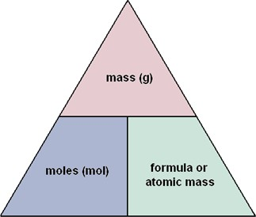To obtain number of moles
      1. Mass / Molar Mass
      2. For example, how many moles of oxygen (O) are there in 64 grams?
      3. 64/16 = 4 Moles
   2. To obtain mass
      1. Number of Moles x Molar Mass
      2. For example, how much grams of Hydrogen gas is present in 5 moles ?
      3. 5 x 2 = 10 grams

## Moles and Concentration

#### Distinguish between the terms solute, solvent, solution and concentration

* 1. **Solute** - A pure substance which would be dissolved in a solvent
     1. Example: Salt and sugar
  2. **Solvent** - A substance where the solute is dissolved
     1. Example: Water
  3. **Solution** - A substance in which a solute is completely dissolved in a solvent
     1. Example: Salt (solute) completely dissolves in water (solvent) to form salt water (solution)
  4. **Concentration** - The proportion of the amount of solute to the volume of the solvent (mol/dm3 or g/dm3)
     1. Concentration = Moles or Mass / Volume
     2. Example - 1 mol of salt in 1 litre of water has a concentration of 1 mol/dm3
  5. **Saturated** - A saturated solution is when the maximum amount of a solute is dissolved in a solvent at a specific temperature
     1. Factors affecting Saturation:
        1. Temperature - higher the temperature the more kinetic energy amongst the particles meaning there would be more space between the particles of the solvent for the solute to dissolve in. Solubility increases as temperature increases
        2. Pressure - it reduces the volume of the solvent compressing more solute into less solvent.
        3. Chemical composition - The nature of the solute and solvent affects solubility
  6. **Saturated** - A solution where no more of the solute can be dissolved into the solvent at a specific temperature
  7. **Saturation** - The degree of extent to which solute is dissolved in a solvent compared to the maximum capacity. The proportion of solute to solvent.

#### Solve problems involving concentration, amount of solute and volume of solution

* 1. (figure 1) Concentration (c) = Number of moles (n) / Volume (v)
  2. If the amount of a substance is given in grams we must first convert that to moles using the formula
  3. (figure 2) Number of moles (n) = Mass (m)/Molar mass(Mr)
  4. Refer to Edmodo for more practice questions

n

c X v

m

n X Mr

## Figure 1 Figure 2

#### Define STP and SATP

* 1. STP - Standard Temperature and Pressure
     1. Standard temperature is 0° celsius
     2. Standard pressure is 1 ATM or 100k pascals
  2. SATP - Standard Ambient Temperature and Pressure or RTP (Room Temperature and Pressure)
     1. Standard ambient temperature is 25°C
     2. Standard pressure is 1 ATM or 100k pascals

#### Calculation of reacting volumes of gases using Avogadro’s Law

* 1. Formulas to calculate for number of moles
     1. Solid = Mass / Molar Mass
     2. Liquid = Concentration x Volume
     3. Gas = Volume / Molar Volume (STP or SATP)
  2. Avogadro's Law - Equal volumes of all gasses when measured at the same temperature and pressure contain equal number of particles.
  3. Molar Volume - The volume occupied by one mole of gas at a given temperature and

pressure.

* + 1. At STP, 1 mole of gas (6.023 x 1023 particles) occupies **22.7 dm3** at 0 C° and 100kPa
    2. At SATP, 1 mole of gas (6.023 x 1023 particles) occupies **24 dm3** at 25 C° and 100kPa

## Practical Applications

#### Calculate the percentage composition by mass of a compound from its formula

* 1. % of the mass of an element in a compound =

100 x (Number of atoms of the element x RAM / Relative formula mass of the compound)

* 1. Example: Water (H2O)
     1. % of mass of oxygen = 100 x (1 x 16 / 18)

= 88.89% of H2O is oxygen

#### Use equations to calculate the masses of reactant and products

* 1. CaCO3 + 2HCL → CaCl2 + H2O + CO2
  2. Calcium Carbonate = 20g
  3. Calculate mass of CO2
     1. First balance chemical equation
     2. Then convert the mass of calcium carbonate to moles

iii. Mass / Molar Mass = 20 / 40 + 12+ (16 x 3) = 20 / 100 = 0.2 moles

1. Use mole ratio to compare 1 mole of CaCO3 gives out 1 mole of CO2
2. Since ratio is 1:1
3. CO2 = 0.2 moles
4. Mass of CO2 = Moles x Molar Mass

viii. Mass of CO2 = 0.2 x 12 + (2 x 16) = 0.2 x 44 = 8.8g

#### Calculating the limiting reactants

* 1. Limiting reactants - The limiting reactant determines how much product can be formed.
  2. Yield - The yield from a chemical reaction is the mass of product made.
  3. Theoretical Yield - The theoretical yield is the quantity of the product that can be formed from the complete conversion of the limiting reactant. This assumes that the reaction is 100% effective, i.e. all of the starting material (reactants) is converted to the desired product.
  4. Actual Yield = The amount of product actually produced is the actual yield. Not a 100% conversion of reactants to products

𝐴𝑐𝑡𝑢𝑎𝑙 𝑦𝑖𝑒𝑙𝑑

* 1. Percentage yield =

### 𝑇ℎ𝑒𝑜𝑟𝑒𝑡𝑖𝑐𝑎𝑙 𝑦𝑖𝑒𝑙𝑑

x 100

* 1. To calculate % yield = Make a balanced equation. Work out the relative formula mass of compounds involved and then use the formula.
  2. Example:
     1. CaCO3 → CO2 + CaO
     2. If 22 grams of CO2 is produced with the decomposition of one mole of calcium carbonate, what is the percentage yield of this experiment?
     3. The theoretical yield assumes that 1 mole of CO2 was produced because the mole ratio between calcium carbonate and carbon dioxide is 1:1.
     4. Mass of one mole of CO2 = 12 + (2 x 16) = 12 + 32 = 44 grams
     5. Percentage Yield = (Actual / Theoretical) x 100 = (22 / 44) x 100 = 50%
  3. Reasons for inefficient reactions and actual yields:
  4. The reaction may be incomplete.

1. Some product is lost during practical preparation.
2. There may be unwanted reactions taking place.
3. Can be difficult to separate the product from other products
4. The product may be impure.

## Skills

#### Differentiate between qualitative and quantitative chemistry

|  |  |
| --- | --- |
| **Qualitative** | **Quantitative** |
| Branch of chemistry that concerns with any non- numerical data, conclusions and observations. | Branch of chemistry that concerns numerical data such as calculations and measurements |

1. **Describe and explain change as either physical or chemical**

|  |  |
| --- | --- |
| **Physical** | **Chemical** |
| Physical change is a change in state but not in the chemical makeup of the substance. | Chemical change occurs in a chemical reaction and the substance's chemical makeup is changed. The process is either exothermic or endothermic. |
| Can be reversed using simple means. Eg: heating cooling, evaporating, etc.. | Cannot be reversed using simple means. Eg: cooling, heating, evaporating etc.. |
| Water → Ice | Egg, Flour, Sugar → Cake |

#### Identify the difference between empirical and molecular formulae

|  |  |
| --- | --- |
| **Empirical** | **Molecular** |
| The formula form of the simplest whole ratio number of atoms in a compound | The formula form of the actual numbers of atoms in a compound |
| Ex: The simplest form of Glucose would be CH2O | Ex: The actual formula of Glucose is C6H12O6 |

1. **Investigate and calculate the empirical formula of a compound**
   1. The empirical formula of a compound can be calculated by:
      1. Using percentage composition
      2. If the percentage values of elements present in a compound are given, divide the percentage compositions by the respective molar mass of each element
      3. For example, 10.8% of Magnesium - 31.8% of Chlorine - 57.4% of Oxygen

*10*.*8*

* + 1. Mg = 24 so,

*24* = 0.45

*31*.*8*

v. Cl = 35.5 so, *35*.*5* = 0.9

*57*.*4*

vi. O = 16 so, *16* = 3.59

1. The next step is to divide these values by the lowest value obtained
2. In this case, Magnesium has the lowest value (0.45)

*0*.*45*

ix. Mg = *0*.*45* = 1

*0*.*9*

x. Cl = *0*.*45* = 2

*3*.*59*

xi. O = *0*.*45* = 8

1. The values that have been obtained are the subscript values for each element in the compound
2. Therefore this compound is MgCl2O8

#### Differentiate between subscripts and coefficients in a chemical equation

* 1. In a chemical equation there are two numbers:
     1. Subscripts; O2 Subscripts notate the number of the specific atom in the chemical equation. WHEN BALANCING AN EQUATION SUBSCRIPTS CANNOT BE CHANGED
     2. Coefficients: 2HCl Coefficients notate the number of specific molecules present

#### Deduce chemical equations when all reactants and products are given

* 1. C + O2 = CO

2C + O2 = 2CO (add a coefficient before the molecule to balance the equation)

* 1. SO2 + O2 = SO3 2SO2 + O2 = 2SO3

#### Convert cm3 to dm3

|  |  |
| --- | --- |
| **cm3** | **dm3** |
| 1 | 0.001 |
| 1000 | 1 |
| **dm3** | **litre** |
| 1 | 1 |
| 1000 | 1000 |
| **ml** | **litre** |
| 1 | 0.001 |
| 1000 | 1 |

1. **Develop laboratory techniques relating to titrations**
   1. Titration is an experimental technique used to identify the concentration of a certain volume of a solution using a known solution with a known concentration value called the titrant
   2. The known solution is slowly added to the other solution until the reaction neutralises
   3. A universal indicator is then utilised to observe the colour change in the solution will be used to identify the concentration
   4. In order to determine the amount the concentration of the unknown solution, the formula n = cv can be used.
      1. The number of moles is determined using the mole ratio of the chemical reaction.

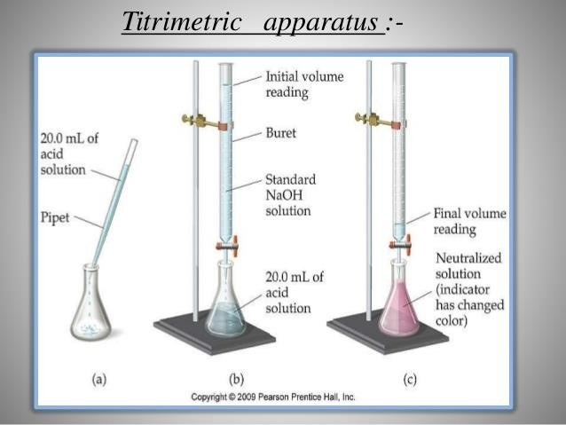e.

1. Let’s take an example where 50 cm3 of 0.2 mol/dm3 of Sodium Hydroxide is required to

neutralise 25 cm3 of Sulphuric Acid with an unknown concentration. Identify the concentration of the acid?

* 1. Write down a balanced equation: 2NaOH + H2SO4 → Na2SO4 + 2H2O
  2. Identify the number of moles: Moles = Concentration x Volume = (50 / 1000) x 0.2

= 0.05 x 0.2 = 0.01 moles

* 1. Identify the number of moles of the acid through the mole ratio: NaOH to H2SO4 is 2:1 therefore 0.01 / 2 = 0.005 moles of H2SO4
  2. Calculate the concentration of the acid: Concentration = Moles / Volume = 0.005 / (25 / 1000) = 0.005 / 0.025 = 0.2 mol/dm3

# 

# **Chapter 9:** How are environmental systems sustained by their chemistry? (Atmosphere)

|  |  |
| --- | --- |
| **Subtopic** | Objectives |
| Atmospheric Composition | * Outline the current composition of air * Describe the fractional distillation of air * Explain how the composition of air has changed over time * State the characteristics of different atmospheric gases * Describe how to test for different atmospheric gases |
| Greenhouse Effect | * Describe the Greenhouse Effect * Describe the formation and depletion of ozone in the stratosphere by natural processes * List the main greenhouse gases and their sources and discuss their relative effects * Outline how CFC’s have affected the ozone layer * Evaluate the Carbon Footprint of different activities and different countries |
| Nutrient Cycling | * Describe how carbon is cycled * Describe how nitrogen is cycled * Describe how phosphorus is cycled |
| Air & Water Pollution | * Describe the main sources of air pollutants (carbon monoxide, nitrous oxides, sulphurous oxides, particulates, and volatile organic compounds) * Outline how the atmosphere interacts with the water cycle * Outline the different ways in which pollution is caused |

## Atmospheric Composition

#### Outline the current composition of air

* 1. Oxygen = 21%
  2. Nitrogen = 78%
  3. Carbon Dioxide = 0.03%
  4. Argon and other noble gases = 0.97%

#### Describe the fractional distillation of air 3 easy steps to remember:

1. Compression of air into the refrigeration unit
2. Filtration to remove solid impurities
3. Distillation column with a temperature gradient
   1. Air is first filtered to remove any fine dust particles, and then is cooled to a temperature of -200oC
   2. At -200oC, the air has liquified
   3. Once the air liquefies, the water vapour contained in the air condenses and is removed using filters
   4. Carbon, Oxygen, and Nitrogen liquify at different temperatures. Carbon freezes at -79oC, Oxygen liquifies at -183oC, and Nitrogen liquifies at -196oC.
   5. Carbon Dioxide and Ice (deriving from water vapor) are removed using absorbent filters. The liquid nitrogen and oxygen are separated by fractional distillation.
   6. Like the separation of crude oil, the top of the column is cooler than the bottom of the column.

#### Explain how the composition of air has changed over time

* 1. Earth’s new atmosphere has less carbon dioxide, less water vapour and more oxygen compared to earth’s older atmosphere
     1. Less Carbon Dioxide - As oceans formed, carbon dioxide in the atmosphere dissolved into the water causing a huge decrease in the amount of carbon dioxide in the atmosphere, but now due to excessive pollution and the release of greenhouse gases, the CO2 parts per million is increasing.
     2. Less Water vapour - As the earth cooled after its formation , water vapour in the atmosphere condensed to form liquid rain which formed the oceans
     3. More oxygen - As the number of plants increased on earth, more photosynthesis occured allowing for more oxygen to be released into the atmosphere

#### State the characteristics of different atmospheric gases

|  |  |
| --- | --- |
| **Gases** | **Characteristics** |
| Argon | * Inert noble gas * Low melting and boiling point * Colourless and odourless |
| Carbon Dioxide | * Colourless and odourless * Soluble in water, ethanol and acetone * Low melting and boiling point |
| Oxygen | * Low melting and boiling point * Diatomic element * Highly reactive * Colourless and odourless |
| Nitrogen | * Generally inert (unreactive) * Colourless, odourless and tasteless * Diatomic element |

1. **Describe how to test for different atmospheric gases**

#### Test for Carbon Dioxide

* + 1. If a gas bubbled through colourless lime water (calcium hydroxide) turns the limewater milky or cloudy (calcium carbonate), then this gas is Carbon Dioxide.
    2. Also, if a wooden splint on fire is added into a test tube with CO2, the fire will extinguish.

#### Test for Chlorine

* + 1. If a gas turns damp litmus paper from blue to red and then bleaches it, then this gas is Chlorine.

#### Test for Hydrogen

* + 1. If an ignited (lit) wooden splint makes a squeaky pop sound when it burns in a gas, this gas is Hydrogen

#### Test for Oxygen

* + 1. If a glowing wooden splint, that was once ignited but blown out, reignites in a gas, then this gas is Oxygen.

#### Test for Water

* + 1. If a liquid turns anhydrous copper (II) sulphate crystals from white to blue, then this liquid is water
    2. If cobalt chloride paper turns from blue to pink, there is water or **water vapour**

present.

#### How the Miller-Urey experiment shows how life began on Earth:

Their experiment: A mixture of different compounds were exposed to sparks to stimulate the extensive lightning which may have been present in Early stages of the Earth’s development.

After a few days, amino acids were found, which are the molecules that build up proteins. This shows that by stimulating what the Earth’s early atmosphere as like, it was visible that several organic compounds could be formed spontaneously.

## Greenhouse Effect

#### Describe the Greenhouse Effect

* 1. The greenhouse effect is used to describe the way the gases in the atmosphere trap heat

from the sun, creating an ‘insulating blanket’ over the Earth.

* 1. Briefly, some solar radiation is reflected of the Earth and some absorbed. It is re-emitted in all directions from the natural greenhouse gases present in the atmosphere, and is a way of warming up the Earth’s surface and lower atmosphere.
  2. Augmented production of greenhouse gases further enhances the greenhouse effect, to the point where heat cannot escape the atmosphere and thus keeps the earth in a period of intense warming.
  3. Geothermal heat and energy produced by the Earth as well gets trapped.

#### Describe the formation and depletion of ozone in the stratosphere by natural processes

* 1. Ozone is an allotrope of oxygen gas, and made naturally in the atmosphere
  2. Oxygen gas molecules are bombarded by high energy UV light from the Sun. This causes the oxygen molecules to break up to form oxygen radicals.
  3. The oxygen radicals react with existing oxygen gas molecules making ozone
  4. Ozone gas molecules are hit by UV radiation from the Sun, and they split into oxygen molecules and radicals. Other ozone molecules then react with oxygen radicals forming oxygen molecules.

#### List the main greenhouse gases and their sources and discuss their relative effects

|  |  |
| --- | --- |
| **Methane** | |
| Source | * Agricultural practices (rice agriculture and paddy fields, biomass burning, anaerobic decomposition in wetlands. * 40% Energy sources, 31% Agricultural sources, 29% Waste management, 1% Industrial process. |
| Solution | Eat less red meat, support organic farming practices, support farms which use ‘digesters’. Anaerobic digesters utilize microorganisms to decompose cattle manure within a container. The resulting biogas can be collected for producing electricity.  Use cleaner forms of combustible gases. Support farms which use organic farming processes. |

|  |  |
| --- | --- |
| **Sulfurous Oxides** | |
| Source | * Combustion of fossil fuels for electricity production (mainly coal, oil and natural gases) and mechanized transport * Smelting of metals copper, zinc, lead, and nickel * Volcanic eruptions * Burning of wood |
| Solution | Utilizing renewable and alternative fuel sources and modes of energy such as solar, tidal, geothermal, wind etc.  Wet Scrubbers - A technique used to channel all dirt gases into a chamber that is mixed and dissolved into liquid that is usually water  Fluidized Bed Consumption: Crushed coal is burned in a bed of Limestone which absorbs the Sulfur that is released from the coal during Combustion.  Removal of Sulfur from Coal: Coal Cleaning reduces Sulfur content by 40%. Advanced Coal cleaning methods reduce it even more. |

|  |  |
| --- | --- |
| **Nitrous Oxides** | |
| Source | Use of synthetic fertilizers for agriculture (nitrification and denitrification), fossil fuel combustions, livestock and manure, biomass burning |
| Solution | Use less nitrogen fertilizer, use minimum tillage for cropping (this minimises organic matter breakdown and the release of nitrous oxides), prevent waterlogging, use more public transport |

|  |  |
| --- | --- |
| **Carbon Monoxide** | |
| Source | Incomplete combustion of fuels, |
| Solution | Have your heating system, water heater and any other gas, oil, or coal burning appliances serviced by a qualified technician every year. Use catalytic converters and unleaded fuel in cars to control gas output and combustion rate. |

|  |  |
| --- | --- |
| **Carbon Dioxide** | |
| Source | Deforestation (9% of total production) as well as the burning of fossil fuels such as coal, oil and natural gas (87% of total production) and industrial processes (4% of total production). |
| Solution | Stop deforestation and advocate for the conservation of plant life, plant trees to sequester carbon. Use industrial processes which may be less effective but rely less on fossil fuels and rely more on cleaner forms of energy etc. |

1. **Outline how CFC’s have affected the ozone layer**
   1. Sunlight breaks up the CFCs, with the Chlorine radicals reacting with the Ozone molecules. The reaction turns Ozone molecules into Oxygen molecules without absorbing any UV lights, causing ozone layer depletion.

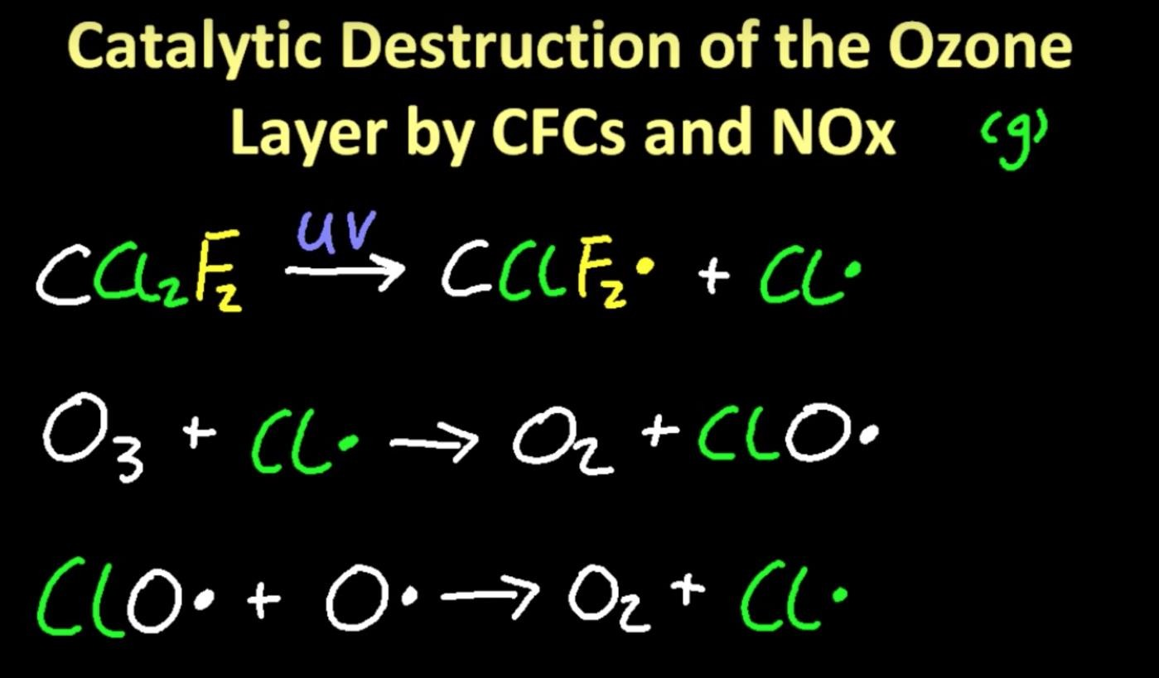

1. **Evaluate the Carbon Footprint of different activities and different countries**

## Nutrient Cycling

#### Describe how carbon is cycled

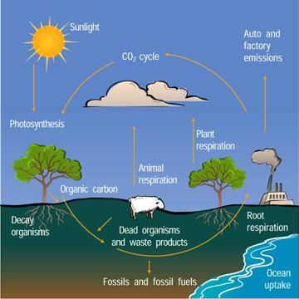

1. **Describe how nitrogen is cycled**

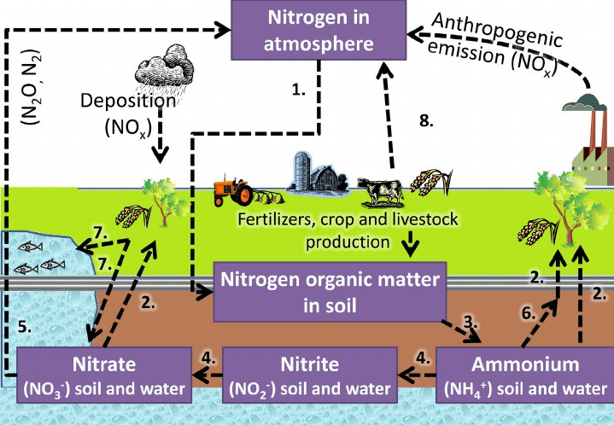

1. **Describe how phosphorus is cycled**

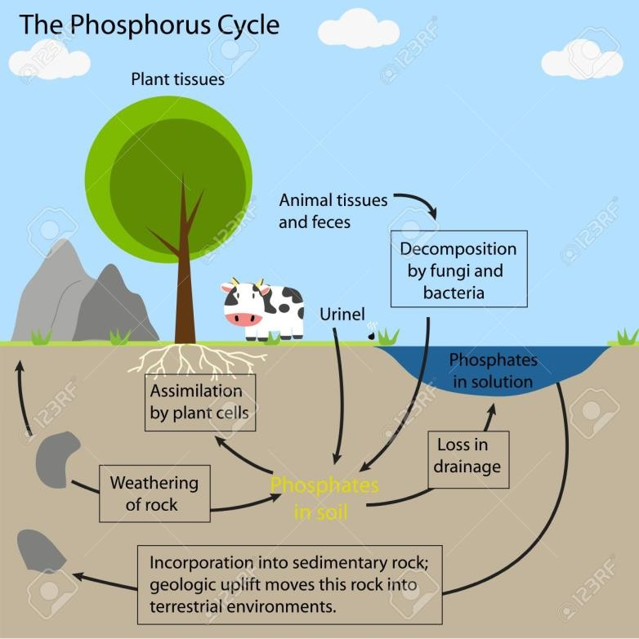

## Air & Water Pollution

#### Describe the main sources of air pollutants (carbon monoxide, nitrous oxides, sulphurous oxides, particulates, and volatile organic compounds)

* 1. Carbon Monoxide
     1. Petrol vehicles without catalytic converter
     2. Power stations and waste incinerators
     3. Cigarette smoking
  2. Nitrous Oxides
     1. Decomposition of nitrogen compounds by bacteria
     2. High temperature combustion in vehicles
  3. Sulphurous Oxides
     1. Volcanic activity and the decay of organic matter
     2. Combustion of coal in the presence of sulphur
     3. Sulphuric acid plants
  4. Volatile Organic Compounds
     1. Paint and furniture polish and finish products
     2. Detergents and aerosols
     3. Smoke and cigarettes

#### Outline how the atmosphere interacts with the water cycle

1. **Outline the different ways in which pollution is caused.**
   1. Burning of fossil fuels for electricity production and in mechanized vehicles emitting carbon monoxide and carbon dioxide
   2. Decomposition of waste material releasing methane and nitrous oxides

# **Chapter 10:** How can our energy resources be accessed fairly? (Enthalpy)

|  |  |
| --- | --- |
| Subtopic | Objectives |
| Combustion | * Define the terms flash point; ignition temperature * Explain incomplete & complete combustion * State word & balanced chemical equations for incomplete & complete combustion * Link combustion equations to exothermic equations |

#### Link combustion equations to exothermic equations

* 1. All combustion reactions are considered to be exothermic as the end product are usually heat and light. This corresponds with exothermic reactions as there is heat given off as a product similar to combustions. Therefore, it can be said that combustion equations are exothermic as they release heat energy to the the surroundings.

**Chapter 11:** How can we shift the balance of a reaction?

|  |  |
| --- | --- |
| Subtopic | Objectives |
| States of Matter & Kinetic Theory | * State the properties of matter (s, l and g) * Describe the kinetic theory in terms of the movement of particles whose average energy is proportional to temperature |
| Collision Theory | * Describe the collision theory * Explain collision theory taking into account the qualitative effects of particles whose average energy is proportional to temperature |
| Equilibrium | * Define the thermal dissociation, reversible reaction and thermal decomposition * Outline the characteristics of chemical and physical systems in a state of equilibrium * State and explain the effect of a catalyst on an equilibrium reaction * Apply Le Chatelier's principle to predict the qualitative effects of changes of temperature, pressure and concentration on the positions of equilibrium * Apply the concepts if equilibrium to the Haber processes and use le Chatelier to create the maximum yield of Ammonia |
| Rate of Reaction | * Define the term rate of reaction * Describe suitable experimental procedures for measuring rates of reaction * Analyse data from rates experiments * Explain factors which affect reaction rate: effects of particle size, temperature, concentration and pressure and presence of a catalyst * List and describe the limitations of each rate of reaction experiment |
| Catalysts | * Define the term activation energy (Ea) * Describe the effect of a catalyst on a chemical reaction |

## States of Matter & Kinetic Theory

#### State the properties of matter (s, l and g)

* 1. The three states of matter (excl. Plasma and Bose Einstein Condensate) are solids, liquids and gases
  2. Solids are denoted by ‘s’
  3. Liquids are denoted by ‘l’
  4. Gases are denoted by ‘g’
  5. Refer to Chapter 1 for properties of each states of matter

#### Describe the kinetic theory in terms of the movement of particles whose average energy is proportional to temperature

* 1. All matter is composed of particles constantly in motion. The movement of particles is proportional to the amount of energy they possess
     1. Particles with high energy move quicker
     2. Particles with low energy move slower
  2. Energy is directly proportional to the temperature of the particles
     1. The greater the temperature, the greater the energy and the quicker the movement
     2. The lower the temperature, the lesser the energy and the slower the movement

## Collision Theory

#### Describe the collision theory

* 1. The collision theory is a theory that explains the rate of chemical reactions in the gas phase based on the kinetic energy of particles
  2. The collision theory also involves the geometry of collision and how it determines whether a reaction takes place or not.

#### Explain collision theory taking into account the qualitative effects of particles whose average energy is proportional to temperature

* 1. The collision theory revolves around the amount of energy particles possess that are needed to break and make bonds for a reaction to take place
  2. For reactions to take place, particles require a minimum amount of energy that will overcome the forces between molecules and break bonds. This minimum energy required is known as activation energy.
  3. If particles of the reactants have a high temperature, they possess greater kinetic energy and move quicker
  4. Particles with greater kinetic energy display more motion. As these particles move more, the probability of them successfully colliding with sufficient energy increases. When these particles collide with sufficient amount of energy that is equal to or greater than the activation energy, the particles react and products are formed.
  5. This theory also involves the geometry of collisions between particles.
     1. If this collision geometry is correct, particles react with each other and the products are formed.
     2. If the collision geometry is incorrect, the particles bounce off each other and no product is formed.

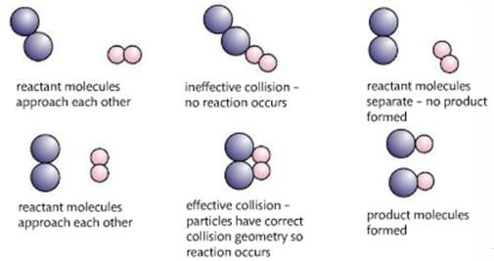

## Equilibrium

#### Define the thermal dissociation, reversible reaction and thermal decomposition

* 1. Thermal dissociation is an easily reversible thermal decomposition reaction in which usually a single bond is broken, when the temperature is increased.
  2. Reversible reactions are those in which the reactants react to form the products and the products can react together to form the reactants.
  3. Thermal decomposition is the chemical decomposition of a substance into many smaller substances at high temperatures. This process involves the breaking and rearrangement of many bonds and is therefore not so easily reversible.

#### Outline the characteristics of chemical and physical systems in a state of equilibrium

* 1. Physical System
     1. If water is being heated, the water molecules gain enough energy and escape the liquid state to become water vapour by evaporation.
     2. At the same time, these gas molecules lose energy condense back to form liquid water molecules.
     3. When the rate of evaporation is equal to the rate of condensation then the system has reached equilibrium.
  2. Chemical System
     1. In a chemical reaction, there are two reactions taking place; the forward reaction between the reactants to form the products and the backward reaction between the products to form the reactants.
     2. When the rate of the forward reaction is equal to the rate of the backward reaction then the system has reached equilibrium.
  3. A system that is in a state of equilibrium will have a fixed ratio between the concentration of products and reactants.
  4. A system in dynamic equilibrium takes place when the rate of the forward reaction is equal to the rate of the backward reaction in a closed system.
  5. At equilibrium there are no changes to the macroscopic or observable properties of the products and reactants after the reaction. For example: the colour and density observed of the reactant and products will remain the same after the experiment is completed.

#### State and explain the effect of a catalyst on an equilibrium reaction

* 1. 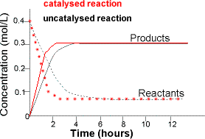The presence of a catalyst does not affect the position of equilibrium. However, a catalyst increases the rates of both forward and backward reactions and thus brings a closed system to equilibrium more rapidly.

#### Apply Le Chatelier's principle to predict the qualitative effects of changes of temperature, pressure and concentration on the positions of equilibrium

* 1. Le Chatelier’s principle is a set of rules that investigate how physical changes to a system in

dynamic equilibrium will shift the position of equilibrium to counteract the physical

changes in order to maintain equilibrium.

* 1. In simple words, if a dynamic equilibrium is disturbed by changing the conditions, the position of equilibrium moves to counteract the change.
  2. This principle shows that a change in the position of equilibrium of a reaction will affect the concentration of the reactants and products when dynamic equilibrium is achieved again.
  3. For instance, if the position of equilibrium of a reaction shift to the reactants then the concentration of reactants will increase and the concentration of products will reduce and the concentration ratio will differ to the original reaction.

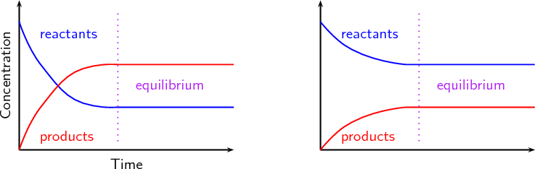

|  |  |  |
| --- | --- | --- |
| **Factor** | **Effect** | **Illustration** |
| **Concentration** | If the concentration of element A increases then the position of equilibrium will shift to the reaction which produces less of element A. |  |
| If the concentration of element A decreases then the position of equilibrium will shift to the reaction which produces more of element A. |  |
| **Pressure**  Pressure is the number of gas molecules present amongst the reactants and products. In the case of the illustration provided, there are 3 gas molecules of reactants and 2 gas molecules of products. Thus, the reactants have greater pressure than the products. | If the pressure of a reaction is increased then the position of equilibrium will shift to the reaction which has lesser pressure (gas produced). |  |
| If the pressure of a reaction is decreased then the position of equilibrium will shift to the reaction which has greater pressure (gas produced). |  |
| **Temperature**  In the case of the illustration, the forward reaction is exothermic and gives out heat energy. The | If the temperature of a reaction increases then the position of equilibrium will shift to the reaction that is endothermic. |  |

|  |  |  |
| --- | --- | --- |
| backward reaction is endothermic and absorbs heat energy. | If the temperature of the reaction decreases then the position of equilibrium will shift to the the reaction that is exothermic |  |

#### Apply the concepts of equilibrium to the Haber processes and use le Chatelier to create the maximum yield of Ammonia

* 1. The Haber Process is chemical process that is utilised by industrialists to produce ammonia by reacting nitrogen and hydrogen at specific conditions

b. N2 + 3H2 ⇆ 2NH3 △H = -92 kJ mol-1

1. Temperature:
   1. The reaction takes place at a compromise temperature of 400-450º C
   2. This temperature is comparatively high and increased from standard temperature which would shift the position of the equilibrium to the reverse reaction. This is because the forward reaction is exothermic and the reverse reaction is endothermic. This produces more reactants and decreases the concentration ratio of products to reactant.
   3. However, if the temperature was reduced then the reaction would take years for it to complete. Thus, a compromise temperature is set to ensure that the reaction takes place quick enough to produce a reasonably high proportion of ammonia (15%).
2. Pressure:
   1. The reaction takes place at a compromise pressure of 200 ATM
   2. This pressure is higher than standard pressure which would shift the position of equilibrium to the forward reaction. This is because the reactants have 4 molecules of gas as compared to 2 gas molecules of products. This produces more products and increases the concentration ratio of products to reactants.
   3. Keeping the pressure at this value would also ensure the rate of reaction is increased and reasonably quick.
   4. An extremely high pressure value is not used in this scenario as it is highly expensive to produce and utilise high pressure as the cost of equipment and maintenance would exceed the potential revenue gained from the production of more ammonia.
3. Catalyst
   1. Catalysts do not have an effect on the position of equilibrium.
   2. Finely powdered iron catalysts are solely utilised to increase the rate of reaction.
   3. In the absence of a catalyst, the reaction is so slow that virtually no reaction happens in any sensible time and no or limited ammonia would be produced.

## Rate of Reaction

#### Define the term rate of reaction

* 1. The speed of a complete reaction that tests the time taken for a complete reaction to take place.
  2. The formula for rate of reaction is: ROR =

𝑉𝑜𝑙𝑢𝑚𝑒 𝑜𝑓 𝑃𝑟𝑜𝑑𝑢𝑐𝑡

𝑇𝑖𝑚𝑒

#### Describe suitable experimental procedures for measuring rates of reaction

* 1. Surface Area - To use marble (calcium carbonate) stones with different surface areas and

react that with hydrochloric acid to observe the amount of carbon dioxide collected after a certain period of time.

* 1. Temperature - To react sodium thiosulphate at different temperatures with hydrochloric acid to observe the time taken for a thick, white solution to form over a cross on a sheet of paper.
  2. Concentration - To react a fixed mass of magnesium ribbon with different concentrations of hydrochloric acid to observe the amount of hydrogen gas produced in a certain amount of time.

#### Analyse data from rates experiments

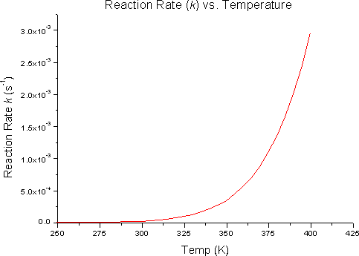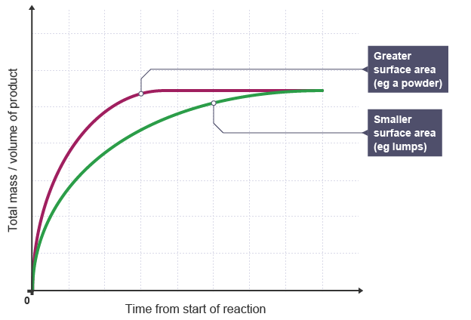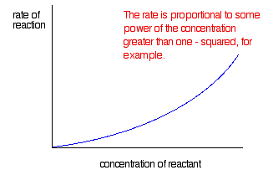

* 1. Temperature - As temperature of the reaction increases the rate of reaction increases as well. The graph to the right displays a positive exponential curve which indicates that the rate of reaction is exponentially increasing as temperature increases.
  2. Surface Area (Particle Size) - As the surface area of the reactants increases the rate of the reaction increases as well. The graph displays two negative exponential curves; one that indicates the use of reactants with a high surface area and the other with low surface area. The graph shows that the curve of greater surface area stabilises at an earlier point than the curve of smaller surface area. Additionally, it can be noted that the gradient of the greater surface area curve is higher than that of the smaller surface area curve.
  3. Concentration - As the concentration of the reactants increases the rate of the reaction increases as well. The graph displays a positive exponential curve which indicates that the rate of reaction is exponentially increasing as concentration increases.
  4. 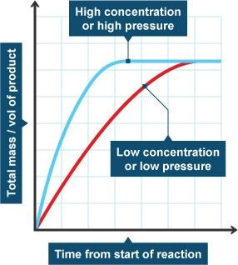Pressure - As the pressure of the reaction increases the rate of the reaction increases as well. The graph displays two negative exponential curves; one that indicates a reaction performed at a high pressure and the other with low

pressure. The graph shows that the curve of high pressure stabilises at an earlier point than the curve of low pressure. Additionally, it can be noted that the gradient of the high pressure curve is higher than that of the low pressure curve.

* 1. Catalyst - As the presence of a catalyst increases the rate of reaction increases. The graph displays three negative exponential curves which indicate the use of more, less and no catalyst in the reaction. The graph shows that the curve of more catalyst stabilises at an earlier point than the curve of less catalyst by producing the highest

amount of oxygen gas. The no catalyst curve produces limited amount of oxygen and

would take far more time to reach the same level as the other curves.

#### Explain factors which affect reaction rate: effects of particle size, temperature, concentration and pressure and presence of a catalyst

* 1. Particle Size (Surface Area) - Particles with a greater size or surface area increase the rate of reaction. This is because the greater surface area of the particles are exposed to other particles resulting in a **greater probability of successful collisions** and a quicker reaction. This is only applicable for solid reactants.
  2. Temperature - Reactions conducted at higher temperatures increase the rate of reaction. This is because the greater the temperature, the greater the thermal energy the particles possess which cause them to vibrate and move quickly and collide with each other with greater energy and more frequently thus **increasing the probability of successful collisions leading to a quicker reaction.**
  3. Pressure - Reactions conducted at higher pressure increase the rate of reaction. This is because the **reactant particles are located closer together and are in concentrated region** increasing the possibility of successful collisions leading to a quicker reaction. This is only applicable for gas reactants.
  4. Catalyst - Catalysts provide an **alternative pathway** where not as much energy is required for the reaction thus occurs much faster. It **reduces the activation energy needed** to overcome the intermolecular forces, which makes it easier to get the reaction going.

1. **List and describe the limitations of each rate of reaction experiment**

|  |  |  |
| --- | --- | --- |
| **Common Limitations for all Experiments** | | |
| **Limitation** | **How does it affect the data?** | **How will it be improved** |
| **Range of IVs** | A larger range of (independent variable) would decrease the chances of outliers making the data collected more reliable. Too small a range means a reliable trend would not be able to identified | An experiment with more than 5 IVs (or how many used in your context) for example 7 IVs such as (0.2, 0.4, 0.6, 0.8, 1, 1.2, 1.4  mol/dm^3) A greater range of IV would allow for a more reliable trend to be identified |
| **Number of Trials (5)** | Though 5 trials is sufficient enough to identify a trend, an increase in the number of trials would allow for outliers to be discounted making the data more reliable and accurate | Increase number of trials from 5 to 10 leading to more accurate and reliable results |

|  |  |  |
| --- | --- | --- |
| **Effect of Temperature on ROR** | | |
| **Limitation** | **How does it affect the data?** | **How will it be improved?** |
| Determining the end of the reaction | When various individuals are assigned towards judging the completion of a reaction, their evaluation may differ from one another due to bias causing imprecise results. | To assign a specific person to monitor and assess whether a reaction is complete or not which would maintain consistency is results obtained. |
| Uncertainty of Thermometer | The analog thermometer had a high uncertainty of ±0.5℃ and as it is based on each person’s interpretation of the reading. This leads to imprecise and inaccurate results overall. | A digital data logger could be used as this digitally records the temperature of the solution to a desired degree of accuracy over a certain period of time.This has a smaller uncertainty than the thermometer hence will provide more precise and accurate data. |

|  |  |  |
| --- | --- | --- |
| **Effect of Surface Area on ROR** | | |
| **Limitation** | **How does it affect the data?** | **How will it be improved?** |
| Size of Marble Chips | Since surface area has an effect on ROR, the same sized marble chips should be used per trial meaning, a chip with a bigger surface area shouldn't be dropped in the trial testing smaller surface area as it would make the data unreliable and inaccurate | This will be improved by using a file to shape the marble chips to a fixed size and length allowing for individuals to identify links of specific surface area values to the rate of reaction |
| Temperature of Reaction | Since the reaction is exothermic, heat is released during the reaction of the chips and the acid, this means all the trials will occur at different temperatures and since temperature affects the rate of reaction the data obtained would be imprecise. | This can be controlled by placing the conical flask in a water bath of constant temperature at 25 degrees celsius and recycling the water after every experiment and making sure the water is at 25 degrees after every recycle using a thermometer |
| Size of the Measuring Cylinder | The size of the measuring cylinder used to collect the amount of carbon dioxide formed was insufficient leading to the collection of invalid and incomplete results. | To utilise a larger measuring cylinder of 300 Cm3 that collects the complete amount of carbon dioxide produced allowing for the collection of valid results.. |

|  |  |  |
| --- | --- | --- |
| **Effect of Concentration on ROR** | | |
| **Limitation** | **How does it affect the data?** | **How will it be improved?** |
| Water Bath | The water bath was not recycled after each experiment which lead to varying initial temperature of the solutions as the experiment is exothermic. This would have caused the rates of reaction to increase for the later experiment leading to imprecise results. | This will be improved by recycling the water bath after each experiment using water from the same source t and by using a thermometer to ensure that the initial is kept constant. |
| Contaminated Equipment | The boiling tube that was utilised to store the solution was not rinsed and cleaned after each experiment which would have affected the concentration of the solution leadings to unreliable results. | To thoroughly rinse and clean the boiling tube with distilled water after each experiment to ensure that the concentration of the solutions are controlled. |
| Time allowed for reaction to take place | The time allowed for the reaction to take place can be described as insufficient as some reactions did not fully complete which would have lead to the collection of inaccurate results. | To increase the time allowed for the reaction to take place to 40 seconds allowing reactions to be completed. |
| Concentrations of the Solutions | The concentration of the solutions were measured using a measuring cylinder which would have yielded inaccurate measurements. Due to this, inaccurate results would have been obtained. | To utilise more accurate measuring equipment such as a burette to measure the volume of acid and water for the solution. |

## Catalysts

#### Define the term activation energy (Ea)

* 1. The minimum amount of energy required for a reaction to take place.
  2. The activation energy is unique and different to every reaction based on the reactants involved.
  3. The activation energy of a reaction is the difference between the energy value of the highest point on the energy curve and the energy value of the reactants.

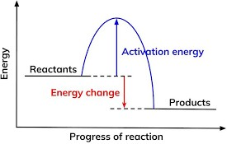 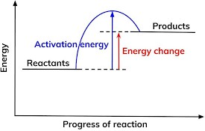

#### Describe the effect of a catalyst on a chemical reaction

* 1. Catalysts are substances that are employed to change the rate of a reaction without being used up.
  2. They provide an alternate path for reaction to take place.
  3. When catalysts are used in chemical reactions, they reduce the activation energy thereby reducing the time taken for the reaction.
  4. This is because the alternate reaction pathway provided has a lower activation energy than the original, uncatalysed reaction

# Frequently Asked Exam Style Questions (FAEQ)

## Diffusion

1. When 5g of zinc carbonate is placed on the right of a evaporating basin filled with 10 cm3 distilled water and 5 g of lithium fluoride is added to the left, a white precipitate (zinc fluoride) will form. On which side of the basin will the precipitate form? (Usually 2-3 marks). This question may in the form of writing a hypothesis.
   1. Calculate the molar mass of both compounds
      1. Zinc Carbonate = 125 g/mol
      2. Lithium Fluoride = 25 g/mol
   2. Using this information and knowledge on the rate of diffusion, you can say that Zinc Fluoride is formed to the right side, where zinc carbonate was added.
   3. If equal masses (5g) of zinc carbonate and lithium fluoride were added to distilled water then the zinc carbonate precipitate will form closer to the side where the zinc carbonate was added. This is because the molar mass of the lithium fluoride (25g/mol) particles is smaller which means that these particles move and diffuse quicker and more easily than zin carbonate.

Separation Techniques

1. Evaluate the use of distillation as a water purifying method
   1. Describe the process of distillation with context to water purification
   2. List and explain 2 general advantages and disadvantages and then link these to a factor (economic and environmental are usually two good factors)
      1. Economic - Opens up job opportunities and provides an essential good and service to citizens of a country. Allows people to work and benefits the economy. However, process is extremely expensive and not economically sustainably in poorer and lesser economically developed countries.
      2. Environmental - Industrial distillation filters and cleans out water for drinking and tap usage. While waste products are safely dumped. However, when done on large scale, usually lots of energy is required to boil water which leads to the burning of fossil fuels, releasing greenhouse gases such as carbon dioxide which increase the global temperature.
   3. Provide a further advantage or disadvantage depending whether you are for or against the use of distillations as a method of water purification
      1. Advantages - Distillation is a simple and easy process that provides many job opportunities for the local public.
      2. Disadvantages - Distillation does not always yield 100% pure or distilled water and may not be very efficient and is costly.
   4. Summarise all your points into an appraisal where you conclude whether distillation is good or bad based on your identified points. Ensure that if you are for then you should have 3 advantages and if you are against you should have 3 disadvantages.
2. Labelling chromatography apparatus

* Chromatogram
* Ink Dyes
* Pencil (For Pencil Line)
* Beaker

# Common Lab Apparatus

|  |  |  |
| --- | --- | --- |
| Apparatus | Image | Notes |
| Round Bottomed Flask |  | They are used to uniformly heat or boil the contents of the flask. They have a curved bottom, which means that no substances can get stuck or accumulate in one area, hence the word uniform. Can be used to measure only 250 cm3 of liquid. Denoted by a ring along the neck. |
| Flat Bottomed Flask |  | Same purpose as the round bottomed flask. The key difference is that they can stand on their own and not have to be clamped, unlike round bottomed flask. |

|  |  |  |
| --- | --- | --- |
| Conical Flask |  | Conical flasks are commonly used in reactions in which the flask may need to be closed with a rubber bung in order to prevent any product from escaping or to measure the volume of gas produced. They are also used when the flask has to be swirled, as the edges prevent spilling. They consist of measurements with regular intervals. Used in titrations. |
| Measuring Cylinder/ Graduated Cylinder |  | They are used for measuring the volume of liquids **accurately and quickly.** More accurate than flasks and beakers. Normally used to dispense a known amount of liquid. They are not as precise as pipettes/ volumetric flasks in terms of measuring the volume of a liquid. |
| Volumetric Flask |  | They are used for measuring a known quantity of liquid. Similar to the flat bottomed and round bottom flask, they contain a ring which denotes how the volume of liquid present. |
| Beaker |  | A beaker is a container used for mixing, stirring or heating up liquids. They have spouts for pouring. |

|  |  |  |
| --- | --- | --- |
| Pipette |  | A pipette is used to transfer a small amount of liquid. |
| Burette |  | Burettes are also used for measuring the volume of a liquid. They are commonly used in titrations, and the main distinction is the fact that you can control the volume of the liquid with the tap. |
| Evaporating Basin |  | An evaporating dish is used for the evaporation of solutions. |
| Distillation Flask |  | A distillation flask is used in simple distillation. |
| Liebig Condenser |  | Used in distillation. Cold water flows through the outer part of the condenser, cooling the inner tube. This allows for the gas that is collected in this tube to condense and form a liquid. |